**Optimizing Operations: A Comprehensive Management System for Accredited Lodging Dormitories and Boarding House at Cebu Technological University - Argao Campus**

A Capstone Project

Presented to Information Technology Department

**Cebu Technological University**

Argao Campus

Lamacan, Argao, Cebu

In Partial Fulfillment of the Requirements for the Degree of

BACHELOR OF SCIENCE IN INFORMATION TECHNOLOGY

**PHILIP JOHN BONBON**

**JOHN ROLAND ABAD**

**MEA SARAH JEAN PALIS**

**ROCELYN LONZAGA**

**JESSEL ANN ORTEGA**

JANUARY, 2025

**TABLE OF CONTENTS**

Pages

**TITLE PAGE i**

**PROJECT ADVISER APPOINTMENT FORM ii**

**PROJECT WORKING TITLE iii**

**TRANSMITTAL LETTER iv**

**PROPOSAL HEARING NOTICE FORM v**

**CHAPTER I 1**

**The Problem and Its Scope 1**

**Introduction 1**

Rationale of the Study  **1**

Theoretical Background **3**

**Review of Related Literature and Studies 6**

Related Literature  **6**

Related Studies  **8**

**STATEMENT OF THE PROBLEM 15**

**SCOPE AND LIMITATIONS OF THE STUDY 18 SIGNIFICANCE OF THE STUDY 19**

**RESEARCH METHODOLOGY 21**

Design 21

Flow of the Study 22

Project Environment or Locale of the Study 25

Respondents 26

Data Instrument 28

Treatment of Data 32

**SYSTEM METHODOLOGY 33**

REQUIREMENTS SPECIFICATION 33

Non-functional requirements 33

TECHNICAL FEASIBILITY 35

SCHEDULE FEASIBILITY (GANTT CHART ) 36

REQUIREMENTS MODELLING (IPO)

OBJECT MODELLING (Flowchart of the system, UCD per actor) 39

DATA DESIGN (ERD) 48

SYSTEM ARCHITECTURE (network topology) 49

LIST OF MODULES 50

TESTING PLAN 53

DEFINITION OF TERMS 55

**CHAPTER I**

**THE PROBLEM AND ITS SCOPE**

**INTRODUCTION**

**Rationale of the Study**

Student accommodation plays a crucial role in the overall success and well-being of students pursuing higher education, especially for those who relocate from their hometowns. As students travel from various regions to enroll in universities or colleges, finding suitable housing becomes a significant challenge. Inadequate access to safe, affordable, and convenient lodging can lead to a negative academic experience. Traditional methods of securing accommodations, such as word-of-mouth or bulletin board listings, are outdated and inefficient. These methods often fail to provide students with essential information about available housing, such as pricing, safety, or amenities.

In response to these challenges, modern web-based accommodation management systems are emerging as essential tools for improving the student housing experience. These systems are specifically designed to provide real-time information and centralized management of housing options, ensuring that students have easy access to the details they need to make informed decisions. However, the reliance on traditional methods persists in many regions, making it difficult to organize and monitor student accommodations effectively. By implementing a user-friendly and centralized platform, institutions can enhance the efficiency of the student housing process, allowing students to find suitable accommodations more quickly and with greater confidence.

The lack of formal accreditation systems further exacerbates the issue. Accreditation is a critical process that ensures lodging facilities meet established certifications, safety, quality, and service standards. Without accreditation, students may be left vulnerable to substandard or unsafe housing options. Accredited accommodations undergo regular inspections and meet defined regulatory standards, ensuring that they provide a safe and conducive living environment for students. This process is vital in guaranteeing that students have access to high-quality lodging that supports their academic success.

**Various studies** have highlighted the need for modern solutions to manage student accommodations more efficiently. A study by Ikhsan (2022) found that outdated manual systems for tracking housing availability often lead to delays and inefficiencies, as students are left to rely on incomplete or inaccurate information. In a global context, manual housing management systems are often resource-intensive, resulting in data inaccuracies that negatively impact decision-making processes. Similarly, in an international study by Lamichhane (2022) titled "Student Housing Challenges in Southeast Asia," the researcher found that the absence of digital information systems led to delays in the housing search process and increased student dissatisfaction. Lamichhane emphasized the need for accreditation systems to ensure that only housing options meeting defined safety and quality standards are offered to students. A local study conducted by Trinidad (2020) in Misamis Oriental, Philippines, revealed that the lack of proper management systems for student accommodations often resulted in unregulated housing markets. Students relying on traditional methods struggled to find suitable, well-maintained accommodations. Paper-based methods for managing accommodation information were found to be labor-intensive and prone to errors, making the process of securing housing tedious and unreliable. These studies underscore the importance of adopting modern, web-based platforms that incorporate accreditation to streamline and improve the student housing experience.

With this in mind, the researcher is motivated to conduct a study on developing a Comprehensive Management System for Accredited Lodging Dormitories and Boarding Houses at Cebu Technological University - Argao Campus, a user-friendly web-based system designed to meet the specific needs of CTU AC students. Through collaboration with stakeholders, including the Student Affairs Office (SAO) and boarding house owners, the system will provide easy access to accredited lodging options. It will furnish comprehensive information on availability, cost, facilities, and boarding categories. Rigorous evaluation and ongoing improvement efforts will ensure usability and efficacy, thereby enhancing student satisfaction with their learning experience and academic performance.

**THEORETICAL BACKGROUND**

This section delves into the theories, concepts, and analytic models pertinent to the topic.

One theory referenced is the Geographical Information System Theory by Amirrudin Hamzah, which underscores the importance of compiling boarding house data and transforming it into actionable information for college students and boarding house owners. The research resulted in an information system with a geographic base that integrates boarding house data and features aimed at assisting college students in finding suitable accommodation (Hamzah, 2021). In the context of the proposed study, boarding house owners can leverage the Geographical Information System Theory as a marketing tool for their establishments, while college students can utilize it as a model to streamline the process of finding a boarding house that meets their needs and is conveniently located near their campus.

The Agile Model Scrum operates on the principle of incremental development and is one of the most widely-used frameworks in agile development for good reason. It offers various benefits and adapts to different project and organization requirements through several common variations. Agile methodology fosters flexibility to adapt to evolving requirements while expediting the delivery of valuable features. Through iterative cycles, it ensures measurable progress and accommodates continuous input and refinement, resulting in a more tailored and reliable solution. Moreover, Agile prioritizes stakeholder involvement, fostering communication and collaboration between developers and end-users, thereby ensuring that the boarding house tracker serves the interests of both proprietors and residents.

The Rent Control Act, also known as Republic Act No. 9653 of 2009, defines rent as the amount paid for the use of a residential unit, typically on a monthly basis unless otherwise specified in a contract. This law authorizes the Housing and Urban Development Coordinating Council (HUDCC) to regulate rental rates of certain residential units and provides safety measures for tenants.

The Rent Control Act of 2009 significantly influences the functionality of our boarding house management system tracker. This law establishes rules regarding rent pricing, lease agreements, tenant rights, and legal compliance in the rental industry. For example, it mandates fair rent prices, affecting how landlords utilize our tracker to set rates for boarding houses. Additionally, it specifies that rent is typically paid monthly unless otherwise stated in the contract, emphasizing the importance of our system in managing payment schedules and agreements. Furthermore, the Act protects tenants from unjust eviction and outlines necessary procedures, highlighting the need for our system to monitor tenant agreements and communication regarding evictions to ensure compliance. By incorporating features that promote adherence to the Rent Control Act, our boarding house management system tracker empowers landlords to operate within legal boundaries while promoting equitable and transparent rental practices.

Geograpical Information System Theory

Agile Model Scrum

Rent Control Act

Republic Act No.9653 of 2009

Proposed System

Challenges in the Current System

**Optimizing Operations: A Comprehensive Management System for Accredited Lodging Dormitories and Boarding House at Cebu Technological University - Argao Campus**

Fig.1 The Theoretical Framework of the Study

**Review of Related Literature and Studies**

This section comprises concepts derived from numerous writers and related studies, serving as the groundwork for this study.

**Related Literature**

The management of student accommodation has undergone a significant transformation due to technological advancements, particularly the integration of web-based systems. This shift has led to the development of innovative solutions like the Comprehensive Management System for Accredited Boarding Houses. Nurul Ikhsan (2022) highlights a persistent challenge faced by university students globally: insufficient housing information. This issue is exacerbated by inadequate online platforms, outdated databases, and transparency gaps. The Accredited Lodging Dormitory Boarding House Management System addresses these challenges by offering a sophisticated integration of web-based platforms aimed at optimizing and streamlining the housing selection process for students.

The functionality of the tracker revolves around accreditation, ensuring that students are presented with a variety of authorized housing options that meet stringent safety and quality standards. This emphasis on transparency and accountability aligns with the findings of Wahyudi et al. (2023), who underscore the importance of these aspects in student housing management. By providing accreditation statuses, safety certifications, and adherence to housing standards, the tracker empowers students to make informed housing decisions.

The accreditation process is typically overseen by institutional authorities, such as the Student Affairs Office, which evaluates and certifies housing options. This ensures that accommodations comply with specific safety, quality, and university policy criteria. The inclusion of certification information administered by such authorized bodies enhances the credibility and reliability of the tracker's data.

Kristianto (2022) outlines the development of the Accredited Lodging Dormitory Boarding House Tracker using established software development methodologies, particularly the Waterfall approach. Despite criticism for its rigidity, the widespread adoption of this model demonstrates its effectiveness in providing tailored solutions for managing student housing.

Models like the Technology Acceptance Model (TAM) shed light on users' perceptions and attitudes toward platforms such as the Accredited Lodging Dormitory Boarding House Tracker. Suwitno et al. (2023) identify positive impacts on perceived ease of use and usefulness perception, indicating user satisfaction with the system's intuitive design and beneficial features. However, further investigation is warranted to address potential limitations in users' attitude toward usage and behavioral intent, presenting opportunities for system refinement and enhancement.

Student accommodation management offers a comprehensive, transparent, and efficient solution to longstanding challenges in housing accessibility, as emphasized by Putra Negara et al. (2021). By leveraging web-based technologies and adhering to accreditation standards, the tracker enhances students' housing experiences, promotes transparency and accountability, and contributes to the overall satisfaction and well-being of the student community.

**Related Studies**

This section delves into a thorough examination of existing pertinent studies that lay the groundwork for comprehending and contextualizing the present research endeavor.

Hamzah and Findawati (2021) undertook an exhaustive study on a boarding house information system in Sidoarjo, employing Geographical Information System (GIS) Theory to enhance the management and accessibility of boarding house data. This system utilizes geographic location data to furnish precise and accessible information crucial for both students and property managers. Its functionalities encompass data compilation and processing, ensuring the accuracy and currency of all boarding house information. Geographic mapping facilitates a visual representation of boarding house locations, aiding users in easily identifying and comparing options based on their geographic preferences. Additionally, search and filtering capabilities allow users to customize their search criteria to find accommodations that best suit their needs.

Highlighting challenges related to trust and reliability in the accommodation search process, the authors identified the difficulties students encounter in verifying the accuracy and authenticity of property listings, which often leads to concerns about the quality and suitability of accommodations. They also underscored the challenge of managing the sheer volume of available options, emphasizing the need for efficient search and filtering functionalities to streamline the housing selection process.

Similarly, Rachmadi et al. (2016) explored the development of a web-based boarding house information system in Yogyakarta, employing the Waterfall Model for its design and implementation. This system incorporates various functionalities aimed at providing a comprehensive and user-friendly platform for managing boarding house information. User registration and authentication features ensure secure access to the system, while an administration panel enables efficient management of listings and system operations. The boarding house search functionality allows users to find suitable accommodations based on specific criteria such as location, price, and amenities, with Google mapping integration providing a visual representation of boarding house locations for easy navigation and comparison.

A well-designed system ensures that students have access to comprehensive and up-to-date information about available housing options, simplifying the search process and facilitating informed decisions. Incorporating user feedback mechanisms and review systems within the boarding house information system provides students with a platform to share their experiences and rate accommodations, fostering transparency and trust in the housing selection process. Moreover, the inclusion of a boarding house owner portal allows property owners to actively manage their listings, optimizing their reach to potential tenants. This emphasis on user engagement and property owner involvement contributes to the overall effectiveness of the information system in facilitating successful housing matches.

Oktavallyan, Seftyarizki, et al. (2021) conducted a detailed study on the health-related design aspects of student boarding houses near the University of Bengkulu, emphasizing the critical importance of health-focused design in student accommodations. Their research meticulously evaluated key factors such as ventilation, natural lighting, and sanitation, demonstrating how these elements contribute to a healthier living environment. Proper ventilation reduces indoor pollutants and ensures fresh air circulation, adequate natural lighting improves mental health and academic productivity, and effective sanitation practices prevent illness and maintain overall hygiene. By focusing on these health-oriented design principles, the study underscores the need to enhance the living conditions in student housing, ultimately supporting students' well-being and academic success.

Strong social support networks, comprising fellow students, landlords, and neighbors, play a vital role in mitigating stress, loneliness, and homesickness among students living away from home (Parazo, R.A. 2016). Community engagement activities foster a sense of belonging and camaraderie among residents, enhancing their mental health and overall satisfaction with the living environment. Promoting a supportive and inclusive community culture within student boarding houses is essential for fostering students' holistic development and well-being. Additionally, integrating sustainable design principles into student boarding houses can contribute to environmental sustainability while providing comfortable and healthy living environments for students.

The Sidoarjo Boarding House System focuses on the quality of student boarding houses, particularly regarding health design, employing the Spiral model for development. Its functionalities include user registration and authentication, an administration panel, a boarding house search feature, a feedback and review system, a notification system, and search and filtering capabilities. This approach underscores the critical role of integrating health and safety considerations into student accommodation platforms to enhance living conditions and overall student satisfaction. The comprehensive system design addresses various health and safety concerns, thereby improving the quality of student accommodations.

The Yogyakarta Boarding House Information System is a web-based platform designed to provide reliable and accessible housing information for students. Developed using the Waterfall model, it features essential components such as user registration and authentication, an administration panel, Google mapping integration, a boarding house information display, a feedback and review system, a boarding house owner portal, and a notification system. The emphasis is on incorporating modern technological solutions to aid students in making informed accommodation choices. The centralized platform caters to the needs of both students and boarding house owners, ensuring efficient and effective communication and management.

The Tangerang City Boarding House System employs the Multi-Attribute Utility Theory (MAUT) method to provide comprehensive information for boarding house providers. Its features include decision support functionalities, detailed information displays, booking and reservation features, messaging and communication tools, and an admin panel. Advanced decision-making tools assist students in efficiently finding suitable accommodations. The sophisticated multi-attribute decision-making methods enhance user satisfaction and operational efficiency. The comprehensive features significantly contribute to the streamlined management of student accommodations, ensuring a more user-friendly and informative platform for students seeking housing.

Table 1

**COMPARATIVE MATRIX FOR RELATED PROJECTS**

|  |  |  |  |  |
| --- | --- | --- | --- | --- |
| **System/Features** | **Sidoarjo Boarding house system** | **Yogyakarta**  **Boarding House Information System** | **Tangerang City Boarding House** | **CTU AC Boarding house tracker** |
| **Tenant Management** | **✓** | **✓** | **✓** | **✓** |
| **Admin/Owner Management** | **✗** | **✓** | **✓** | **✓** |
| **Superadmin/Student Affairs Office (SAO) Management** | **✗** | **✗** | **✗** | **✓** |
| **Room Availability Management** | **✗** | **✓** | **✓** | **✓** |
| **Google Mapping** | **✓** | **✓** | **✓** | **✓** |
| **Review and Rating** | **✓** | **✓** | **✓** | **✓** |
| **Mobile Accessibility** | **✗** | **✗** | **✗** | **✓** |
| **Owner Compliance Document Management** | **✗** | **✗** | **✗** | **✓** |
| **Signup and Login** | **✓** | **✓** | **✓** | **✓** |
| **Record keeping of tenants** | **✓** | **✗** | **✗** | **✓** |
| **Total Percentage:** | **50%** | **60%** | **60%** | **100%** |

**Legend: ✓ - Applicable ✗ - Not Applicable**

**STATEMENT OF THE PROBLEM**  
 The objective of this study is to meet the demand for a well-organized and effective monitoring system for authorized lodging dormitories and boarding houses utilized by students at Cebu Technological University-Argao Campus. More precisely , it aims to examine ,devise, construct, and put into operation a thorough tracker known as the Optimizing Operations: A Comprehensive Mangement System for Accredited Lodging Dormitories and Boarding Houses at Cebu Technological University – Argao Campus.  
In particular, this study aims to address the following inquiry:  
1. What is the current status of Boarding House Management System of Argao Cebu as accredited CTU-AC SAO in terms of  
 1.1 Accreditation  
 1.2 Room Allocation;  
 1.3 Safety and Security;  
 1.4 Accomodation;  
 1.5 Communication and   
 1.6 Maintenance Management  
2. Based on the Aforementioned status, what are problem met by the respondents ?  
3. What features should be included in the development of the new system?  
4. What is the quality of the new system as rated by IT experts using the ISO 9126 for Software Quality Standard in terms of;

4.1. Functionality;

4.2. Reliability;

4.3. Usability;

4.4. Efficiency;

4.5. Maintainability; and

4.6. Portability?  
5. How will the new system be rated by the IT experts and User in terms of;  
 5.1 Perceived ease-of-use; and  
 5.2. Perceived ease-of-usefulness?  
6. Is there a significant difference between the user’s rating and the IT experts’ rating in terms of the perceived usefulness of the system?

**SCOPE AND LIMITATION OF THE STUDY**

This study aims to address the challenges faced by students at CTU Argao Campus in securing suitable nearby accommodation through the development and deployment of the ALDBH Management System at CTU AC, a web-based system. Drawing from the prevalent globalized educational landscape characterized by significant geographic mobility among higher education students, the system aims to furnish vital details about available boarding houses, encompassing their proximity to the campus, cost, amenities, boarding categories and of course to ensure the safety of the tenants where tenants can view the boarding house safeness. The study's scope encompasses several phases, including the design and creation of the web-based system, the incorporation of features to ensure the provision of standardized information, collaboration with stakeholders like the Student Affairs Office and boarding house owners, and the meticulous evaluation of the system's usability and efficacy.

However, the study acknowledges certain limitations. Firstly, it solely concentrates on the development and implementation of the system, disregarding broader housing policy implications. Secondly, external factors such as shifts in the local housing market may impact the system's long-term effectiveness. Additionally, constraints related to data availability and quality may influence the accuracy of the information dispensed by the system. By acknowledging these factors, the study aims to provide valuable insights into enhancing student living experiences and encourages further research to explore additional dimensions of student accommodation needs in higher education settings.

**SIGNIFICANCE OF THE STUDY**

The deployment of the Accredited Lodging Dormitory and Boarding House Management System at Cebu Technological University Argao Campus (CTU AC) carries substantial implications for multiple stakeholders:

**Students:** Through the utilization of the tracker, students receive invaluable support in overcoming the hurdles of securing appropriate accommodation in close proximity to the campus. This tool enables them to make well-informed choices, thereby enriching their overall academic journey and well-being.

**Cebu Technological University Argao Campus:** The incorporation of the tracker underscores the university's dedication to student welfare and achievement. It establishes CTU Argao Campus as an institution devoted to meeting the tangible requirements of its student body, thereby enhancing its reputation as a student-centric university.

**Student Affairs Office (SAO):** The tracker enhances administrative efficiency for the Student Affairs Office (SAO) by consolidating accommodation-related inquiries and expediting housing assignments. This streamlined process enables university staff to allocate resources more efficiently and concentrate on other vital student services.

**Boarding House Owners:** Accredited lodging providers experience heightened visibility and potential occupancy rates by being featured in the tracker. By adhering to accreditation criteria and being listed on the platform, these providers tap into a wider student market, thereby enriching the local accommodation ecosystem.

**Future Researchers:** Understanding the effectiveness and impact of the tracker provides valuable insights that can guide future advancements and innovations in comparable scenarios, fostering ongoing enhancements in student support services. This research paves the way for further exploration in areas such as student accommodation, campus services, and the integration of technology within educational environments.

**RESEARCH METHODOLOGY**

In this section, the methodology utilized for conducting the research study is elucidated. It delineates the research design, approach, and procedures, the demographics of the target respondents, and the study location, along with the tools and techniques employed for data collection and analysis to fulfill the objectives of the Optimizing Operations: A Comprehensive Management System for Optimizing Operations: A Comprehensive Management System for Accredited Lodging Dormitories and Boarding Houses at Cebu Technological University - Argao Campus.

**Design**

The researchers will employ a quantitative and descriptive research approach to provide a comprehensive understanding of the challenges faced by students at CTU Argao Campus and the effectiveness of the ALDBH Management System in addressing these challenges. The study will utilize a descriptive survey to evaluate the tracker based on established software evaluation criteria. These criteria are derived from ISO/IEC 9126-1 Software Engineering standards, focusing on internal and external quality, quality in use, perceived ease of use, and usefulness. Additionally, the system's design will emphasize the usage of an agile model, ensuring a logical sequence of events throughout the development of the system.

**Flow of the Study**

**Input.** The study begins by evaluating the current Boarding House Management System at Cebu Technological University-Argao Campus, focusing on aspects such as accreditation, room allocation, safety, accommodation quality, communication, and maintenance management. It identifies key issues including integration challenges, user adoption resistance, technical reliability, financial constraints, security concerns, operational efficiency, user experience, feedback incorporation, and emergency management. The new system is designed to include features such as effective user management, a reliable booking system, accurate financial tracking, efficient accommodation management, communication tools, compliance features, robust reporting, strong security, and ease of integration.

**Process.** To develop this system, surveys and interviews with users and stakeholders are conducted to gather necessary data and feedback. The existing system is analyzed to identify gaps, and new features are evaluated against these issues. ISO 9126 standards are used to assess system quality, and comparisons are made between user and IT expert ratings for ease-of-use and usefulness. Statistical tests are performed to determine significant differences in ratings, and the system is designed, developed, and tested for integration and usability.

**Output.** The result is a comprehensive management system that effectively addresses the identified problems and incorporates the desired features. This new system is evaluated based on ISO 9126 standards and feedback from users and IT experts, leading to improvements in management, efficiency, and overall user satisfaction.

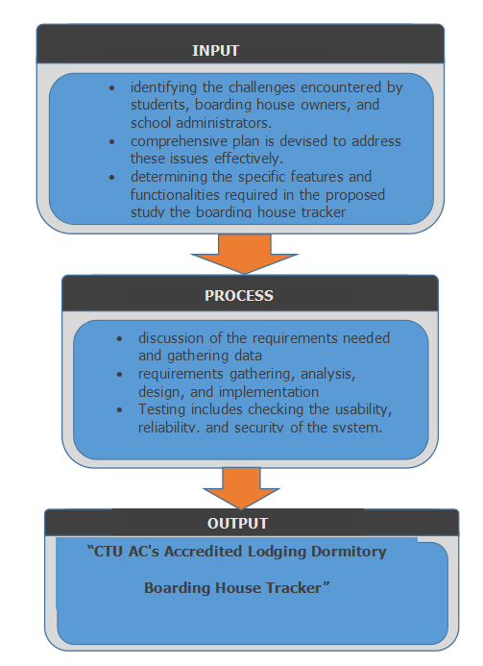

Optimizing Operations: A Comprehensive Management System for Accredited Lodging Dormitories and Boarding Houses at Cebu Technological University - Argao Campus

**· Conduct surveys and interviews with users and stakeholders.**

**· Analyzing**

**· Designing**

**· Implementation**

**· Testing**

**· Evaluate current Boarding House Management System (accreditation, room allocation, safety, accommodation, communication, maintenance).**

**· Identify key issues (integration, user adoption, technical reliability, financial, security, efficiency, user experience).**

**· Outline system features (user management, booking, financial tracking, accommodation management, intuitive UX).**

Fig.2 Flow of the Study

**Project Environment (Locale of the Study)**

The research will take place at Cebu Technological University- Argao Campus (CTU AC) situated in Argao, Cebu. Accredited Lodging Dormitory and Boarding House Management System offers accommodation services specifically designed for students enrolled at CTU AC. As a testament to CTU AC's dedication to student well-being, the boarding house facilitates convenient access to available boarding house options for students, enables efficient management of listings for boarding house owners, and provides school administrators with valuable insights into student housing trends to enhance planning and decision-making processes.

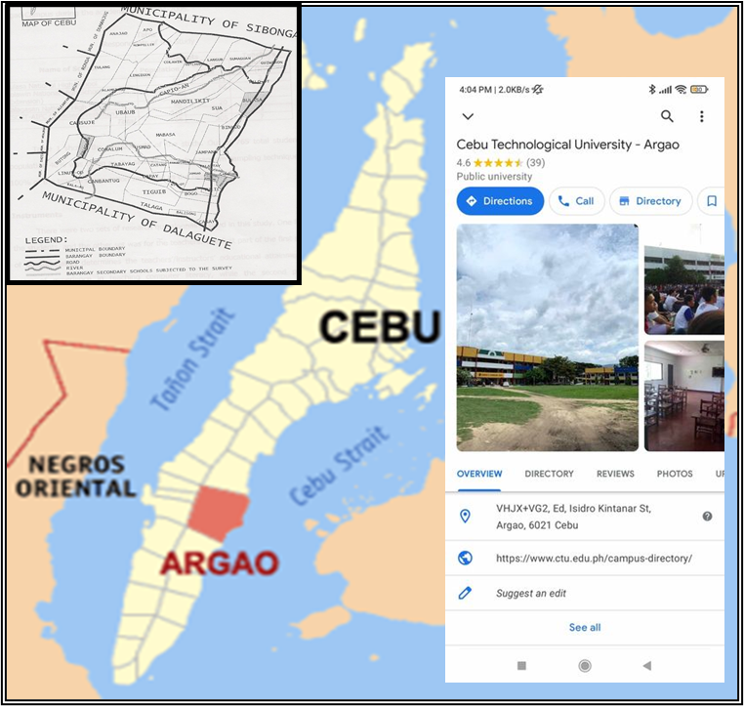

Fig. 3 Map of CTU-Argao Campus

**Respondents**

In the course of conducting this study, the selected participants will primarily consist of key stakeholders involved in the operation and management of Accredited Lodging Dormitory and Boarding House Management System at CTU AC. This includes boarding house owners, representatives from the CTU AC and students who live in the boarding house may also be involved in the research to provide insights from the end-user viewpoint and to assess the efficacy of the accommodations offered. Purposive sampling will be used to ensure the inclusion of persons with appropriate skills and direct engagement in the boarding house's activities. Furthermore, IT professionals may be chosen to evaluate the technological features of the boarding house management system, ensuring that it satisfies the needs of both administrators and students.

Table 2

**TOTAL RESPONDENTS OF THE STUDY**

|  |  |  |
| --- | --- | --- |
| **Respondents** | **n** | **%** |
| **College of Education (COED** | **30** | **9.62** |
| **College of Technology and Engineering (COTE)** | **30** | **9.62** |
| **College of Hospitality Mangement and Tourism (CHMT)** | **30** | **9.62** |
| **College of Agriculture Forestry and Environment (CAFE)** | **30** | **9.62** |
| **IT Experts** | **10** | **0.64** |
| **Owners** | **10** | **0.64** |

**DATA INSTRUMENT**

This study will employ a comprehensive survey questionnaire as its primary data collection tool. The questionnaire is designed to gather insights from various stakeholders involved in the utilization and assessment of ALDBH Management System at CTU AC. It will consist of statements addressing the challenges encountered by students when seeking nearby accommodation, with respondents asked to rate the severity of these challenges using a Likert scale.

Additionally, the survey will evaluate the internal and external quality of the system, assessing its functionality, reliability, usability, efficiency, maintainability, portability, and quality of use. The survey questions will be structured based on the criteria evaluation tool from ISO/IEC 9128, ensuring a standardized approach to evaluating the tracker's quality.

Furthermore, Likert scale questions will be included in the survey to gauge stakeholders' perceptions of the tracker's usefulness, user-friendliness, and acceptance. This aspect draws inspiration from Davis' (1989) study on "perceived usefulness, perceived ease of use, and user acceptance of information technology."

By utilizing this comprehensive survey questionnaire, the study aims to gather a diverse range of perspectives on the ALDBH Management System at CTU AC, facilitating a thorough evaluation of its effectiveness and areas for improvement.

Table 3

1. **Point Compliance Rating Scale**

|  |  |  |
| --- | --- | --- |
| Range | Rating | Description |
| 2.34 - 3.00 | Fully Complied (FC) | MEETS ALL requirements as specified. |
| 1.67 - 2.33 | Partially Complied (PC) | Meet some but NOT ALL requirements. |
| 1.00 - 1.66 | Not Complied (NC) | NOT MEET the required standards . |

Table 4

**Software Evaluation (Internal and External Quality) Criteria**

|  |  |  |  |  |  |  |  |
| --- | --- | --- | --- | --- | --- | --- | --- |
| Range | Rating Scale | Functionality | Reliability | Usability | Efficiency | Maintainability | Portability |
| 3.26 - 4.00 | 4 | Very Functional | Very Reliable | Very Usable | Very Efficient | Very Maintainable | Very Portable |
| 2.51 - 3.25 | 3 | Functional | Reliable | Usable | Efficient | Maintainable | Portable |
| 1.76 -  2.50 | 2 | Slightly Functional | Slightly Reliable | Slightly Usable | Slightly Efficient | Slightly Maintainable | Slightly Portable |
| 1.00 -  1.75 | 1 | NOT Functional | NOT Reliable | NOT Usable | NOT Efficient | NOT Maintainable | NOT Portable |

Table 5

**Software Evaluation (Perceived Usefulness and Perceived Ease-of-Use) Criteria**

|  |  |  |  |
| --- | --- | --- | --- |
| Range | Rating Scale | Perceived Usefulness | Perceived Ease-of-Use |
| 3.26 - 4.00 | 4 | Very Useful | Very Easy to Use |
| 2.51 - 3.25 | 3 | Useful | Easy to Use |
| 1.76 - 2.50 | 2 | Partially Useful | Not so Easy To Use |
| 1.00 - 1.75 | 1 | Not Useful | Not Easy to Use |

**Treatment of Data**

The weighted mean was calculated to account for the varying significance of each data point in the analysis. The formula used is as follows:



where 𝑤𝑖 represents the weight assigned to the 𝑖th observation, and 𝑥𝑖 represents the 𝑖th data point. This approach ensures that data points with higher importance or frequency have a proportionally greater impact on the final mean

**SYSTEM METHODOLOGY**

**REQUIREMENTS SPECIFICATION**

**Non-functional Requirements**

These requirements are intended to guarantee that the system satisfies the expectations of its customers while following to applicable standards and laws.

**Performance**

Images present in the system should be optimize for different screen sizes. In terms also in handling users, it should be smooth to avoid lagging and to provide a good user – experience. Usability - The system is user – friendly where the interface is easy to navigate by the users like the boarding house owners, students and SAO. The system also is responsive in any screen size such as the size of a mobile phone.

**Security**

The system provides a logout and login for all the users; the super admin SAO, the admin BH owners, and the students of CTU AC. Only a registered account can have the access to the said system.

**Maintainability**

 The system must be well maintained from time to time. Putting good documentation to the code can help maintain the system efficiently so that it will be easier to understand and navigate whenever an error is occurring within the system.

**Robustness**

The system continues to operate well, by this it will help maintain a good reliability and user good user experience.

**Responsive Design**

 The system is design to adjust on any view such as laptop and mobile view. This is because students mostly nowadays uses mobile phone and it is also more efficient, quicker to access than using a landscape laptop.  
**Scalability**  
 The system design will be scalable to provide for future increases in the number of certified lodging establishments and inhabitants. Provisions should be made to increase storage space and processing power as needed.

**Technical Feasibility**

For the system to be functional and interactive, software and hardware specifications are needed and it should be identify. The software specification is a program that is require to make the computer behave accordingly. Hardware specification is a tangible equipment use to make the system functional. During the development process, the following software specifications and hardware specifications will be use.

**Software Specifications**

Operation System (OS) – Windows

Programming Environment (IDE) – Visual Studio Code (Community) Version 1.79 and above

Frond-end – HTML, CSS, JavaScript

Back-end – Django, Firebase

**Hardware Specifications**

Processor – Intel core i4 and above

RAM – 3.83GB and above

Hard Disk Drive (HDD) – 464GB and above

**Schedule Feasibility**

In project development, a Gantt chart facilitated meticulous planning and progress monitoring by visualizing the project timeline. Key factors—user requirements, functionalities, costs, time constraints, and developer expertise—were carefully considered beforehand, shaping the project's trajectory and ensuring success within tight constraints.

|  |  |  |  |  |  |  |  |  |  |  |  |  |  |  |
| --- | --- | --- | --- | --- | --- | --- | --- | --- | --- | --- | --- | --- | --- | --- |
|  | Task Name | Start | End | Feb | Mar | Ap | May | Jun | Aug | Sep | Oct | Nov | Dec | Jan |
| **1** | Planning | 2-06-24 |  |  |  |  |  |  |  |  |  |  |  |  |
| **2** | Pre-Proposal |  |  |  |  |  |  |  |  |  |  |  |  |  |
| **3** | Analyzing |  |  |  |  |  |  |  |  |  |  |  |  |  |
| **4** | Designing |  |  |  |  |  |  |  |  |  |  |  |  |  |
| **5** | Proposal | 5-29-24 | 5-30-24 |  |  |  |  |  |  |  |  |  |  |  |
| **6** | Developing |  |  |  |  |  |  |  |  |  |  |  |  |  |
| **7** | Prototyping |  |  |  |  |  |  |  |  |  |  |  |  |  |
| **8** | Testing |  |  |  |  |  |  |  |  |  |  |  |  |  |
| **9** | Final Oral |  |  |  |  |  |  |  |  |  |  |  |  |  |
| **10** | Deploying |  |  |  |  |  |  |  |  |  |  |  |  |  |

Completed        On-Going                           to be completed

Fig.4 Gantt Chart

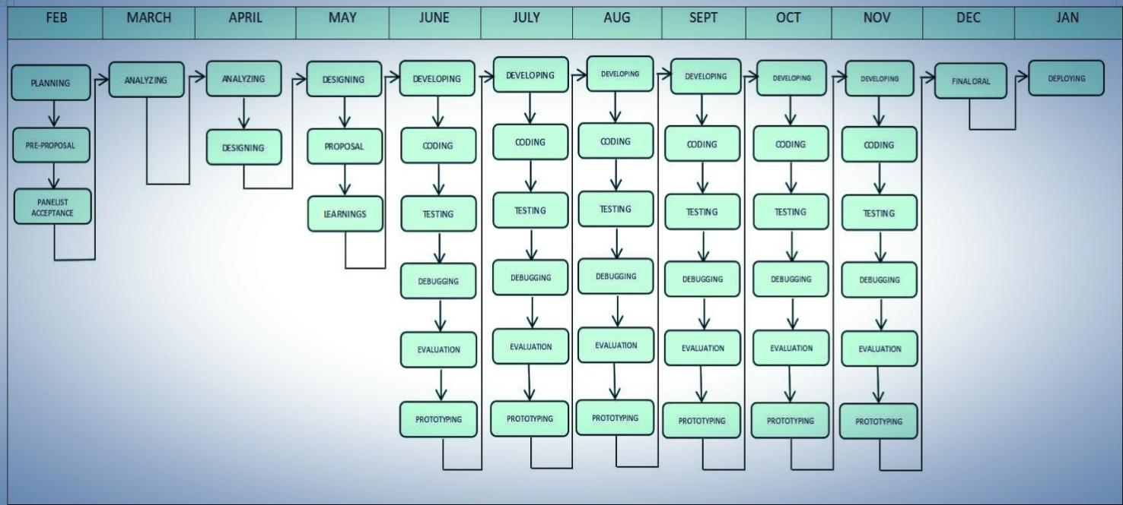

Fig.5 Diagram for Agile Process

**REQUIREMENTS MODELLING (IPO)**

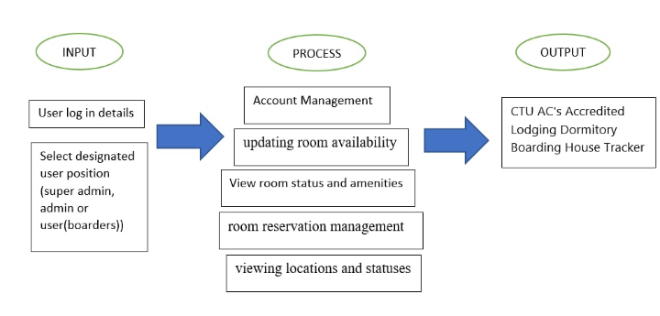

Optimizing Operations: A Comprehensive Management System for Accredited Lodging Dormitories and Boarding Houses at Cebu Technological University - Argao Campus

Fig.6 Input-Process-Output Diagram

The provided diagram above outlines the system's input, process, and output stages. At the input stage, users provide login credentials and select a designated user position, such as super admin, which is the CTU AC's staff, admin, which is the boarding house owner, and the students as boarders, who will be the primary users. The process stage encompasses various logical actions facilitated within the user interface, including account management, updating room availability, room reservations, viewing locations and statuses, monitoring compliance, and other related tasks. Upon execution of these actions, the output produced is the management tool, which serves as a comprehensive platform for managing boarding house operations within CTU AC.

**Object Modelling**

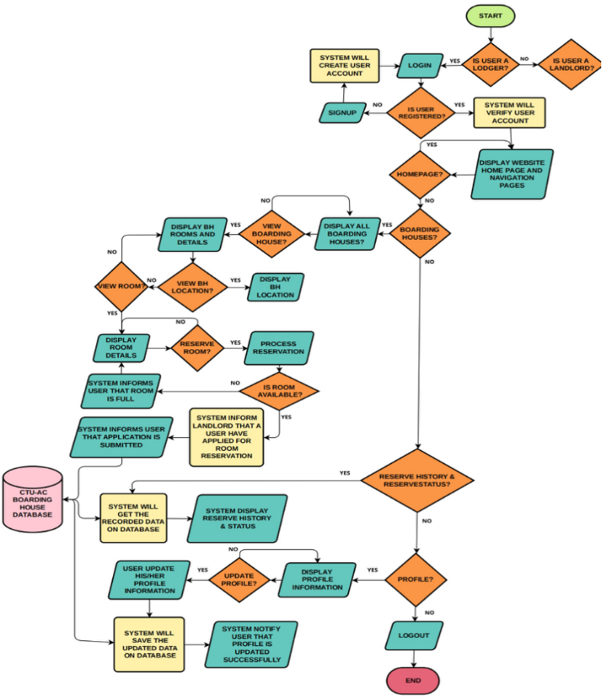

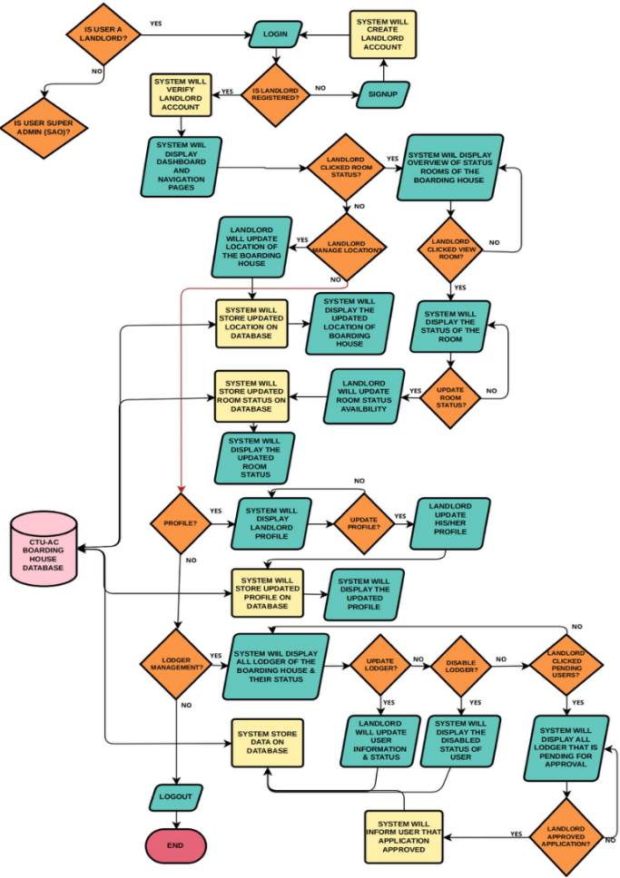

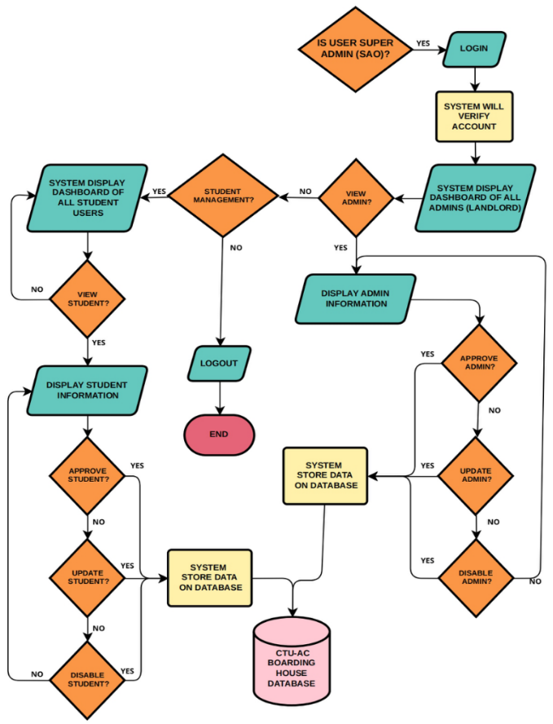

Fig.7 Flowchart of the System

The diagram illustrates the system's flow from input to output. Users choose if Student, Landlord or Super Admin and log in to the website. If User is student then User can browse to all boarding houses that is accredited by CTU-AC, as well as view boarding house’s location, apply for room reservation. They can also view their reserve status and reserve history, and edit their profile.  
   
 Meanwhile if User is Landlord, they can view and update the status of their boarding house and it’s rooms and can modify the location of it as well. They can also update their profile and manage the student Users by viewing, approving, updating or disabling the lodgers or students account. Lastly if User is Super Admin or SAO can view all the landlords and students user and manage them by approving, updating or disabling Users both landlords and students.

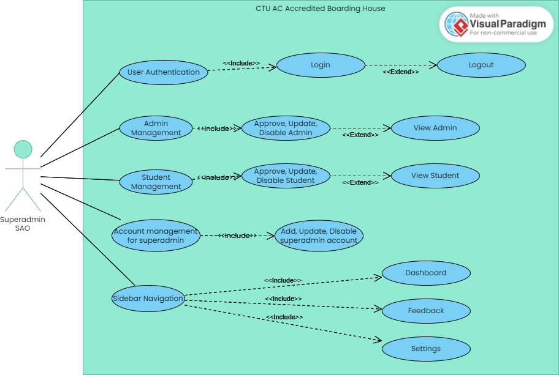

Fig.8 Use Case Diagram for Super Admin (SAO)

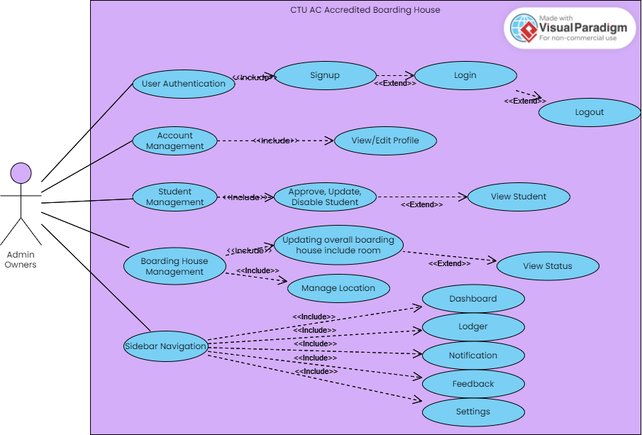

Fig.9 Use Case Diagram for Admin (BH OWNERS)

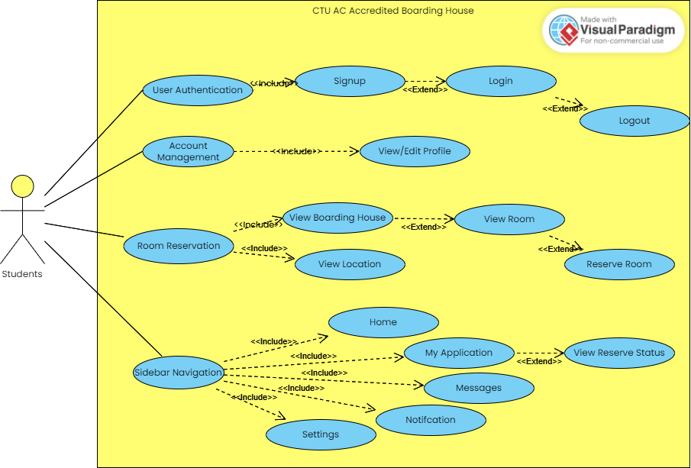

Fig.10 Use Case Diagram for Primary Users (STUDENTS)

The following figures above are the UCD or the Use Case Diagram that make up the system :

**SAO:** The Student Affairs Office or *SAO* stands as the super admin of the system. The SAO accepts or decline the boarding house owners depending if they meet the requirements require to be included as a boarding house accredited by CTU-AC. Only the accredited boarding house of this system are displayed in the students page.

**BH Owners:** The boarding house owners passes requirements during sign-up, this is to let the *SAO* know that their boarding house is legal. The owner also updates the boarding house status like the total of the boarders, the total of person in that room, this is to notify the student if the boarding house is already fully occupied.

**Students:** The students are the one who apply for the boarding house. But first they need to sign-up and login for them to select their preference boarding house. The students also can rate the boarding house.

**DATA DESIGN (ENTITY – RELATIONSHIP DIAGRAM)**

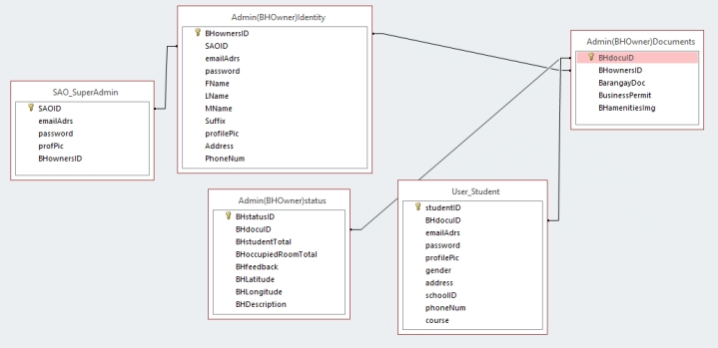

Fig.11 ERD for the ALDBH Management System at CTU AC

The figure shown above is the graphical representation of concepts within an information system and shows their connection to one another. Database implementation is done using Firebase.

**SYSTEM ARCHITECTURE**

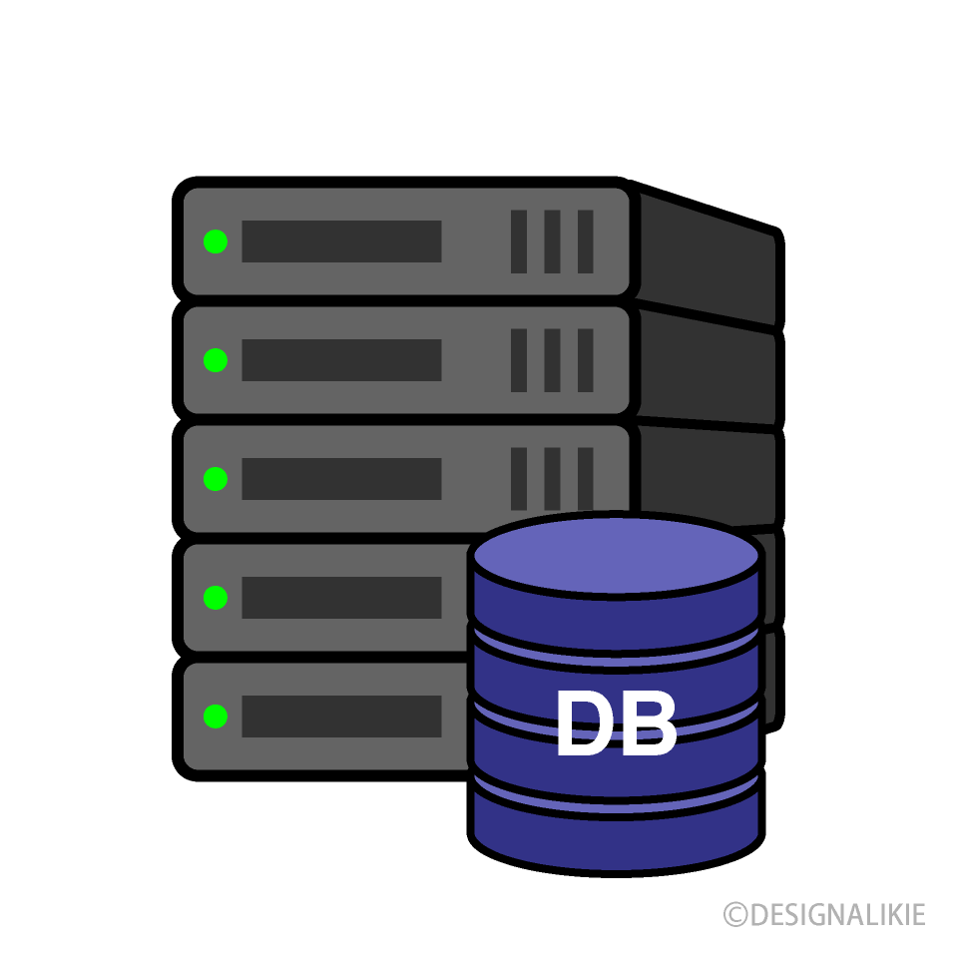

**INTERNET**

**CLIENT WEB BROWSER**

**WEBHOSTING**

**DATABASE SERVER**

Response

Request

Request

Response

Queries

Results

Fig.12 Boarding House Management System at CTU AC : System Architecture

The figure above shows how the system architect works in Accredited Lodging Dormitory and Boarding House Management System at CTU AC. The user interacts through web browser, then it initiates the user’s request to web-hosting. The Web-hosting receives the user request and gives it to the database server. After that the Database Server receive from the web hosting executing the SQL Queries then the Database Server returns the result back to the user’s web. The figure serves as the blueprint offering a visual representation of the system, making it easier to know how the system flows through internet and how it works.

**List of Modules**

1. Superadmin (SAO)
   1. Login
      1. Verify to Login
   2. Forgot Password
   3. Dashboard
      1. View Approved Student
         1. Update
         2. Disable
         3. Remove Role
         4. View profile
      2. View Approved Owners
         1. Update
         2. Disable
         3. Remove
         4. View Full Profile
            1. Owner personal profile
            2. Boarding house profile

Track Location

* + 1. Pending Request
       1. Filter Role
          1. Student pending

Approve

Reject

View Profile

* + - * 1. Owner pending

View Profile

Take action

Approve

Reject

Track Location

* + 1. Student Database
       1. Upload CSV file with new data
       2. Download data as CSV file
       3. Add data using input type
       4. Update
       5. Delete Data
       6. Change pincode
    2. Add Superadmin account
       1. Add account
       2. Change pincode
       3. Request to remove a superadmin account
    3. Voting to remove a superadmin account
  1. Messages
     1. Chat with students
     2. Chat with owners
  2. Feedback
     1. Statistics
     2. View Student Reports
        1. Fix the issue submitted by students
     3. View OwnerReports
        1. Fix the issue submitted by owners
  3. Undo Users Action
     1. Rejected Students
        1. Restore Account to pending
        2. Update Information
     2. Rejected Owners
        1. Restore Account to pending
        2. Update Information
     3. Disabled Students
        1. Restore Account to approve
     4. Disabled Owners
        1. Restore Account to approve
     5. Removed Students
        1. Restore Account to approve
     6. Removed Owners
        1. Restore Account to approve
     7. Removed Superadmin
  4. Settings
     1. Edit Profile
     2. Change Password
  5. Monitor users know IP and link open
  6. Generate Reports
     1. Owners Boarding house data
        1. Filter by status
        2. Download data to PDF
     2. Student Data
        1. Filter by status
        2. Download data to PDF
  7. Logout

1. Admin (Owners)
   1. Login
   2. Signup
      1. Verify account
   3. Forgot Password
   4. Report a problem (no user in session)
   5. Dashboard
      1. Manage Boarding House
         1. Setup location for the boarding house
         2. Save/Update Details
         3. Delete images for amenities and documents
      2. Room Management
         1. Add Room Details
         2. Hide/Unhide rooms
         3. Edit Details
         4. Approve Student removal request
      3. Tenants Management
         1. Remove Tenant/Student applied to your boardinghouse
         2. View Rejected Students
      4. Messages
         1. Chat with sao
         2. Chat with student
   6. Lodger
      1. Approve and give schedule for student t
      2. Reject Student
   7. Feedback
      1. Statistics
   8. Settings
      1. Edit Profile
      2. Change Password
      3. About Us (giving feedback to overall system)
   9. Report a problem (user in session)

1. Students
   1. Login
   2. Signup
      1. Verify account
   3. Forgot Password
   4. Report a problem (no user in session)
   5. Dashboard
      1. Filter boarding house
      2. Applying to boardinghouse
         1. View Boarding House Details
         2. View Location
         3. Apply Rooms
   6. My Application
      1. Cancel applied room
      2. View Details
      3. Request for removal to owner
   7. Notifications
      1. Remove notification
   8. Settings
      1. Edit Profile
      2. Change Password
      3. About Us (giving feedback to overall system)
   9. Report a problem (user in session)
2. 404 Page

**TESTING PLAN**

After developing the application, the researchers will test it in a number of ways to check if it satisfies the objectives and specifications.

1. **Functional Testing**

Functional Testing is a type of software testing that ensures the system or application functions properly. Functional testing for the ALDBH Management System at CTU AC verifies that the system is capable of managing and recording data for accredited lodging establishments, including dormitories and boarding houses. It involves testing functionalities such as adding, editing, and deleting lodging details to check its capability of handling and processing resident data.

Ensure that the CTU employees and lodging administrators can use the application or the software system effectively, efficiently, and conveniently. For instance, in the case of the study, the focus areas would be the reservations, information retrieval, and reporting functionalities. Identify any potential challenges in usability and address them to improve the user experience.

**B.Performance Testing**

Performance Testing is a process that involves evaluating an application or system’s reactivity, scalability, and stability to determine how capable it is of handling numerous tasks. The aim of this assessment is to ensure that it functions properly and satisfies its performance requirements. This includes testing the system to see how quickly it responds in critical functions such as data retrieval, report submission, and user login. The goal is to identify and address any problems to ensure that the system can accommodate a large number of users and data in the future.

**C.Security Testing**

Security Testing focuses on evaluating the security measures implemented in software to identify vulnerabilities and safeguard sensitive information. It is important to analyze the safety measures of the system, such as data encryption, access control, and user authentication. The aim is to find security problems or weaknesses in order to fix them and make improvements.

1. **Integration Testing**

Integration testing is vital in ensuring that modules or segments, such as financial and students’ information capabilities, are compatible and in interaction. This testing is aimed at ensuring that data is seamlessly exchanged between the approved lodging tracker and its affiliates. The ALDBH Management System at CTU AC would then be checked to ensure it appropriately works, from the creation of the user, through reservation management, to data analysis.

**E.Acceptance testing**

Acceptance testing aims to verify that the system satisfies the needs and meets all requirements of the users or stakeholders. It involves testing the system to ensure it operates as expected by the users. Acceptance testing for ALDBH Management System at CTU AC includes testing the system to verify that the lodging administrators can add new entries with ease and that the staff of CTU can create accurate reports using the data in the system.

**DEFINITION OF TERMS**

The following terms are presented theoretically and operationally based on it being used in the study to comprehend better.

**Accommodation** – accommodate to provide someone a room.

**Accredited** – is officially approved by SAO and latter recognized by the CTU AC.

**Admin** – refers to the Boarding House Owners.

**Django** – a back-end framework use for a side server logic and handling request.

**ALDBH Management System at CTU AC** – Cebu Technological University Argao Campus’ Accredited Lodging Dormitory Boarding House.

**SAO** –(Student Affairs Office) refers to the super admin of the system.

**Tracker** – use to track the boarding house location, student status.

**User** – refers to the students of CTU AC as the primary users.

**Firebase** – integrating this to Django framework. This allows Django to interact with Firebase. This also serves as the database of the system.   
  
**CHAPTER 2**

**Presentation, Analysis, and Interpretation of Data**

This chapter presents the data gathered, analyzed, and interpreted to address the study's objectives. It focuses on the current status of the Boarding House Management System accredited by CTU-Argao Campus SAO, examining aspects such as accreditation, room allocation, safety and security, accommodation, communication, and maintenance management. It also identifies challenges faced by respondents which are the students in the current system and presents the development and implementation of the Optimizing Operations: A Comprehensive Management System for Accredited Lodging Dormitories and Boarding Houses at Cebu Technological University – Argao Campus.

**Current status of Boarding House Management System of Argao Cebu**

This section explores the current status of the Boarding House Management System of Argao Cebu. The system currently lacks a digital platform, and students rely on traditional methods such as social media, walk-ins, and other non-digital communication channels to access information and services. The focus is on identifying and categorizing the key issues related to the management processes, particularly in the following areas: accreditation, room allocation, safety and security, accommodation, communication, and maintenance management. These aspects are evaluated to understand the effectiveness of the system and the difficulties students encounter when trying to navigate and utilize it.

The table below provides the weighted mean and corresponding remarks to assess the compliance of requirements of each issue.

Table 6

**Accreditation**

|  |  |  |
| --- | --- | --- |
| **Current status of the Boarding House Management System of Argao Cebu, as accredited by CTU-AC SAO** | **Weighted Mean** | **Remarks** |
| The accreditation process make the boarding house safer and more comfortable for residents. | 2.15 | meet some but NOT ALL requirements |
| The boarding house provide the necessary documents and information to stay accredited. | 2.27 | meet some but NOT ALL requirements |
| The accreditation improves the overall quality of life for residents. | 2.20 | meet some but NOT ALL requirements |
| The boarding house system cover aspects you believe are essential for accreditation (such as safety, comfort, cleanliness). | 2.34 | meet some but NOT ALL requirements |
| The boarding house system, as it is currently, will meet the requirements for future accreditation. | 2.28 | meet some but NOT ALL requirements |
| **AVERAGE WEIGHTED MEAN**  **N = 100** | 2.25 | Meet some but NOT ALL requirements. |

**3-Point Compliance Rating Scale**

**Range**   **Rating**   **Description**

2.34 - 3.00 Fully Complied (FC) MEETS ALL requirements as specified.

1.67 - 2.33 Partially Complied (PC) Meet some but NOT ALL requirements.

1.00 - 1.66 Not Complied (NC) NOT MEET the required standards .

As shown above, the current accreditation status of the Boarding House Management System in Argao, Cebu, as evaluated by 100 participants, reflects that the system "meets some but not all requirements." The weighted means for each area under review indicate that while some aspects of the boarding house system meet the standards, there are still gaps in meeting full compliance.

Accreditation makes the boarding house safer and more comfortable for residents, receiving a weighted mean of 2.15. This indicates partial compliance with the requirements, suggesting that while safety and comfort are addressed, some standards remain unmet. Necessary documents and information to maintain accreditation are provided by the boarding house, with a weighted mean of 2.27. This score suggests that while some necessary documents are submitted, full compliance with accreditation criteria is not yet achieved.

Improvements in the overall quality of life for residents are reflected in a weighted mean of 2.20. While there are positive changes, the system does not fully meet all accreditation criteria in this area. Essential aspects for accreditation, such as safety, comfort, and cleanliness, are covered by the boarding house system, earning a score of 2.34. This places the area within the "Partially Complied" range, indicating that while some key elements are addressed, not all requirements are fulfilled. The system, as it currently stands, is expected to meet the requirements for future accreditation, with a score of 2.28. Although some progress is made, further improvements are necessary to meet the standards for future accreditation.

The average weighted mean for the overall evaluation is 2.25, placing the boarding house in the "Partially Complied" category. This indicates that while it meets some requirements, it does not fully satisfy the accreditation criteria. Further improvements are needed to achieve full compliance and meet all the necessary standards for accreditation.

Addressing and overcoming these challenges would be pivotal for the Boarding House Management System to enhance the efficiency and effectiveness of its current room allocation processes. By focusing on areas such as fairness, accessibility, communication, and resource management, the system can provide a more seamless and satisfactory experience for its residents while moving closer to full compliance with accreditation standards.

Table 7

**Room Allocation**

|  |  |  |
| --- | --- | --- |
| **Current status of the Boarding House Management System of Argao Cebu, as accredited by CTU-AC SAO** | **Weighted Mean** | **Verbal Description** |
| Rate the fairness of the room allocation process. | 2.15 | meet some but NOT ALL requirements |
| The students able to easily request or select specific rooms. | 2.27 | meet some but NOT ALL requirements |
| The students receive enough information about their assigned rooms (e.g., room type, cost). | 2.20 | MEETS ALL requirements as specified |
| The boarding house system avoid issues with overbooking or room shortages. | 2.34 | meet some but NOT ALL requirements |
| How satisfied are you with the communication provided during the room allocation process? | 2.34 | meet some but NOT ALL requirements |
| **AVERAGE   WEIGHTED  MEAN**  **N = 100** | 2.26 | Meet some but NOT ALL requirements. |

**3-Point Compliance Rating Scale**

**Range**   **Rating**   **Description**

2.34 - 3.00 Fully Complied (FC) MEETS ALL requirements as specified.

1.67 - 2.33 Partially Complied (PC) Meet some but NOT ALL requirements.

1.00 - 1.66 Not Complied (NC) NOT MEET the required standards .

The room allocation process of the Boarding House Management System, as evaluated by participants, reflects a status of "meets some but not all requirements," with an average weighted mean of 2.26. This result indicates partial compliance across key areas, highlighting both strengths and areas for improvement.

Fairness in the allocation process received a weighted mean of 2.15, suggesting that while efforts are made to ensure equitable distribution, certain standards remain unmet. The ability of students to easily request or select specific rooms scored 2.27, indicating that while some options are available, additional measures are needed to enhance accessibility and efficiency in this area.

Students are provided with adequate information about their assigned rooms, such as room type and associated costs, as evidenced by a weighted mean of 2.20, which meets all requirements for this criterion. However, challenges persist in avoiding overbooking or room shortages, with this area scoring 2.34. This indicates that while the system partially addresses the issue, there is a need for more robust mechanisms to prevent such occurrences. Similarly, satisfaction with the communication provided during the allocation process also scored 2.34, reflecting that while communication efforts are in place, they do not fully align with the expectations of the students.

Overall, while the system demonstrates progress in several aspects, it remains in the "Partially Complied" category. Further enhancements are necessary to address gaps in fairness, room selection accessibility, and communication, as well as to ensure better management of room availability.

Table 8

**Safety and Security**

|  |  |  |
| --- | --- | --- |
| **Current status of the Boarding House Management System of Argao Cebu, as accredited by CTU-AC SAO** | **Weighted Mean** | **Verbal Description** |
| The boarding house meet safety standards. | 2.22 | meet some but NOT ALL requirements |
| How would you rate the overall security measures in place (e.g., surveillance, security personnel)? | 2.10 | meet some but NOT ALL requirements |
| Emergency exits that are easy to find and access. | 2.18 | meet some but NOT ALL requirements |
| The boarding house provide safety equipment, like fire extinguishers, for emergencies. | 2.03 | meet some but NOT ALL requirements |
| Curfew is in place, and is it effectively enforced to ensure the safety of residents. | 2.31 | meet some but NOT ALL requirements |
| **AVERAGE   WEIGHTED  MEAN**  **N = 100** | 2.17 | Meet some but NOT ALL requirements. |

**3-Point Compliance Rating Scale**

**Range**   **Rating**   **Description**

2.34 - 3.00 Fully Complied (FC) MEETS ALL requirements as specified.

1.67 - 2.33 Partially Complied (PC) Meet some but NOT ALL requirements.

1.00 - 1.66 Not Complied (NC) NOT MEET the required standards .

The data evaluates the current status of the Boarding House Management System in Argao, Cebu, as accredited by CTU-AC SAO, with an overall average weighted mean of 2.17. This indicates that the system "meets some but NOT ALL requirements," highlighting areas for improvement in ensuring the safety and security of residents.

Specifically, the boarding house partially meets safety standards, with a score of 2.22, reflecting moderate compliance but leaving gaps that need addressing. The overall security measures, such as surveillance and security personnel, scored 2.10, suggesting inadequate implementation or effectiveness. Emergency exits, with a score of 2.18, are present but not entirely easy to find or access, which could pose risks during emergencies. The availability of safety equipment, such as fire extinguishers, received the lowest score of 2.03, indicating a serious deficiency in emergency preparedness. Curfew enforcement scored the highest at 2.31, showing relatively better implementation but still failing to fully ensure the safety of residents.

These results emphasize the need for significant improvements in the Boarding House Management System. Priority should be given to enhancing emergency preparedness by providing adequate safety equipment, ensuring that emergency exits are clearly marked and accessible, and improving the overall security measures in place. Additionally, consistent curfew enforcement and regular audits of safety standards are essential to address existing gaps. By addressing these issues, the boarding house can provide a safer and more secure living environment for its residents.

Table 9

**Accomodation**

|  |  |  |
| --- | --- | --- |
| **Current status of the Boarding House Management System of Argao Cebu, as accredited by CTU-AC SAO** | Weighted Mean | Verbal Description |
| The accommodations provided by the boarding house meet your personal needs. | 2.18 | meet some but NOT ALL requirements |
| The boarding house provide a comfortable and inviting living environment. | 2.15 | meet some but NOT ALL requirements |
| The amenities (e.g., common areas, Wi-Fi) sufficient to meet your daily requirements? | 2.25 | meet some but NOT ALL requirements |
| How satisfied are you with the quality of furniture and appliances provided? | 2.20 | meet some but NOT ALL requirements |
| The boarding house environment conducive to studying and personal relaxation. | 2.28 | meet some but NOT ALL requirements |
| **AVERAGE  WEIGHTED MEAN**  **N = 100** | 2.21 | Meet some but NOT ALL requirements. |

**3-Point Compliance Rating Scale**

**Range**   **Rating**   **Description**

2.34 - 3.00 Fully Complied (FC) MEETS ALL requirements as specified.

1.67 - 2.33 Partially Complied (PC) Meet some but NOT ALL requirements.

1.00 - 1.66 Not Complied (NC) NOT MEET the required standards .

Based on the data, the accommodations "meet some but NOT ALL requirements," with an average weighted mean of 2.21. While some aspects of the accommodations meet the necessary standards, there are notable areas for improvement.

The accommodations provided partially meet the personal needs of residents, with a weighted mean of 2.18. This suggests that while the accommodations are somewhat adequate, further improvements are needed to fully address the needs of the residents. The comfort and inviting nature of the living environment scored 2.15, indicating that there is room for enhancement in creating a more comfortable space for residents. Amenities, such as common areas and Wi-Fi, received a slightly higher score of 2.25, reflecting that they are moderately sufficient but still require improvements to fully support the residents' daily needs. The quality of furniture and appliances scored 2.20, highlighting the need for better provisions to enhance resident satisfaction. The highest score of 2.28 was given to the boarding house environment’s conduciveness to studying and personal relaxation, showing a relatively better performance but still short of meeting all requirements.The results underscore the need for improvements in several areas.

Table 10

**Communication**

|  |  |  |
| --- | --- | --- |
| **Current status of the Boarding House Management System of Argao Cebu, as accredited by CTU-AC SAO** | Weighted Mean | Verbal Description |
| The communication between boarding house management and residents is effective. | 2.29 | meet some but NOT ALL requirements |
| Are you promptly informed about updates, events, or important information by the management team? | 2.24 | meet some but NOT ALL requirements |
| The management team for addressing resident concerns or inquiries is accessible. | 2.29 | meet some but NOT ALL requirements |
| There is a clear and reliable way to reach management in case of emergency or urgent matters. | 2.18 | meet some but NOT ALL requirements |
| Residents are encouraged to provide feedback or suggestions to improve the boarding experience. | 1.75 | meet some but NOT ALL requirements |
| AVERAGE  WEIGHTED          MEAN  N = 100 | 2.15 | Meet some but NOT ALL requirements. |

**3-Point Compliance Rating Scale**

**Range**   **Rating**   **Description**

2.34 - 3.00 Fully Complied (FC) MEETS ALL requirements as specified.

1.67 - 2.33 Partially Complied (PC) Meet some but NOT ALL requirements.

1.00 - 1.66 Not Complied (NC) NOT MEET the required standards .

The data highlights the challenges faced by students regarding communication within the boarding house system, with an overall average weighted mean of 2.15, indicating the system "meets some but NOT ALL requirements." While some aspects of communication show moderate compliance, there are evident gaps in effectiveness and responsiveness.

The communication between boarding house management and residents scored 2.29, reflecting that it is somewhat effective but leaves room for improvement. Similarly, the accessibility of the management team for addressing resident concerns or inquiries also scored 2.29, suggesting that while management is reachable, their responsiveness or availability could be enhanced. Students feel moderately informed about updates, events, or important information, as indicated by a score of 2.24. However, the system lacks reliability in communication during emergencies, with a score of 2.18, pointing to the need for a clearer and more reliable method of contact during urgent situations.

The lowest score of 1.75 pertains to the encouragement of residents to provide feedback or suggestions. This highlights a significant deficiency in fostering open and proactive communication, which is critical for improving the boarding experience.

Overall, these findings underscore the need for better communication practices within the boarding house. Management should focus on establishing a more reliable communication system for emergencies, improving the promptness and clarity of updates, and creating a more inclusive environment that actively encourages resident feedback. By addressing these issues, the boarding house can enhance its communication processes and strengthen the relationship between management and residents.

Table 11

**Maintenance Management**

|  |  |  |
| --- | --- | --- |
| **Current status of the Boarding House Management System of Argao Cebu, as accredited by CTU-AC SAO** | **Weighted Mean** | **Verbal Description** |
| The boarding house facilities are well maintained in terms of cleanliness. | 2.26 | meet some but NOT ALL requirements |
| Repair requests are handled promptly by the management. | 2.43 | meet some but NOT ALL requirements |
| How satisfied are you with the frequency and thoroughness of facility inspections? | 2.19 | meet some but NOT ALL requirements |
| The maintenance management ensures that common areas are clean and usable at all times. | 2.29 | meet some but NOT ALL requirements |
| The facilities, such as plumbing, electricity, and air conditioning, are regularly maintained and functioning well. | 2.39 | meet some but NOT ALL requirements |
| **AVERAGE  WEIGHTED MEAN**  **N = 100** | 2.31 | Meet some but NOT ALL requirements. |

**3-Point Compliance Rating Scale**

**Range**   **Rating**   **Description**

2.34 - 3.00 Fully Complied (FC) MEETS ALL requirements as specified.

1.67 - 2.33 Partially Complied (PC) Meet some but NOT ALL requirements.

1.00 - 1.66 Not Complied (NC) NOT MEET the required standards .

The data reveals that students perceive the maintenance of their boarding house facilities as generally adequate but inconsistent, falling into the “Meet some but NOT ALL requirements” category with an average weighted mean of 2.31. While repair requests are handled reasonably promptly (2.43), students express the least satisfaction with the frequency and thoroughness of facility inspections (2.19), indicating a need for more proactive and meticulous checks. Cleanliness, particularly in common areas, also requires improvement (2.26 and 2.29 respectively), suggesting inconsistent cleaning schedules or standards. Additionally, while major facilities like plumbing, electricity, and air conditioning are perceived as generally maintained (2.39), there is still room for improvement to ensure all maintenance needs are met effectively. Overall, the findings point to a need for a shift from a reactive approach to a more proactive maintenance management strategy, with a focus on increasing the frequency and quality of inspections, improving cleaning consistency, streamlining the repair process, and gathering more specific feedback from students to address individual issues.

**ISO 9126 for Software Quality Standard as rated by IT Experts**

The table below shows the different aspects of the functionality, its average  weighted mean, and verbal description.

Table 12

Functionality

|  |  |  |
| --- | --- | --- |
| **Functionality** | **Weighted Mean** | **Verbal Description** |
| Sustainability | 3.8 | Very Functional |
| Accuracy | 3.5 | Very Functional |
| Interoperability | 3.3 | Very Functional |
| Security | 3.9 | Very Functional |
| Functionality Compliance | 3.4 | Very Functional |
| **AVERAGE WEIGHTED**  **MEAN** | 3.58 | Very Functional |

The assessment report reveals that the system is highly functional, with an impressive overall weighted mean of 3.58. The system demonstrates strong sustainability, receiving a weighted mean of 3.8, indicating its ability to maintain reliable operations over time. Its accuracy is also commendable, with a functional rating of 3.5, reflecting its capability to perform tasks with precision. Additionally, the system showcases excellent interoperability, achieving a score of 3.3, signifying its effectiveness in integrating and working with other systems. Security has exceeded expectations, earning the highest score of 3.9, highlighting the system's strong data protection and safe operation capabilities. Furthermore, the functional compliance rating of 3.4 underscores the system's ability to meet required standards and specifications.

In general, the system's grand mean of 3.58 reflects that it is highly functional and successfully fulfills the key characteristics of functionality.

The table below shows the different aspects of the reliability, its average weighted mean, and verbal description

Table 13

**Reliability**

|  |  |  |
| --- | --- | --- |
| **Reliability** | **Weighted Mean** | **Verbal Description** |
| Maturity | 3.6 | Very Reliable |
| Fault-Tolerance | 3.3 | Very Reliable |
| Recoverability | 3.7 | Very Reliable |
| Reliability Compliance | 3.5 | Very Reliable |
| **AVERAGE WEIGHTED**  **MEAN** | 3.53 | Very Reliable |

The assessment report highlights that the system is "Very Reliable," with an average weighted mean of 3.53. The maturity of the system, scoring 3.6, reflects its stability and readiness for consistent performance. Fault-tolerance, rated at 3.3, indicates that the system can effectively handle errors and continue operations without significant disruptions. Recoverability, with the highest score of 3.7, demonstrates the system's strong capability to recover quickly from failures or interruptions. Additionally, the reliability compliance rating of 3.5 confirms that the system adheres well to the required reliability standards.

As a whole, the system's performance under the reliability criteria is impressive, indicating that it is capable of delivering consistent, stable, and dependable functionality.

The table below shows the different attributes of usability, the grand mean and the overall verbal description.

Table  14

**Usability**

|  |  |  |
| --- | --- | --- |
| **Usability** | **Weighted Mean** | **Verbal Description** |
| Learnability | 3.8 | Very Usable |
| Operability | 3.6 | Very Usable |
| Attractiveness | 3.9 | Very Usable |
| Usability Compliance | 4 | Very Usable |
| **AVERAGE WEIGHTED**  **MEAN** | 3.75 | Very Usable |

As shown above, the usability of the Boarding House Management System is evaluated with an average weighted mean of 3.75, categorizing it as "Very Usable." This indicates a strong overall usability performance across key aspects of the system.

In terms of learnability, the system received a weighted mean of 3.8, demonstrating that it is very easy for users to learn and use. Similarly, operability, which measures how effectively users can interact with the system, scored 3.6, reflecting that it is highly usable and functional. Attractiveness, with a score of 3.9, shows that the system is visually appealing, enhancing the overall user experience. Furthermore, usability compliance, scoring 4, indicates that the system fully complies with usability standards, ensuring a seamless and user-friendly experience.

Moreover, the average weighted mean of 3.75 signifies that the system is highly effective and efficient in terms of usability, making it a user-friendly tool for residents and staff alike.

The table below shows the different attributes of efficiency, the grand mean and the overall verbal description.

Table  15

**Efficiency**

|  |  |  |
| --- | --- | --- |
| **Efficiency** | **Weighted Mean** | **Verbal Description** |
| Time-Behavior | 3.3 | Very Efficient |
| Resource Utilization | 3.5 | Very Efficient |
| Efficiency Compliance | 3.9 | Very Efficient |
| **AVERAGE WEIGHTED**  **MEAN** | 3.56 | Very Efficient |

The efficiency of the Boarding House Management System is assessed with an average weighted mean of 3.56, placing it in the "Very Efficient" category. This highlights the system's high level of performance in terms of time and resource management.

Regarding time-behavior, the system received a weighted mean of 3.3, indicating that it performs tasks in a timely manner, contributing to efficient operations. Resource utilization scored 3.5, suggesting that the system makes optimal use of available resources, ensuring smooth functioning. In terms of efficiency compliance, the system scored 3.9, demonstrating its adherence to efficiency standards and showcasing its effectiveness in delivering results.

Overall, the average weighted mean of 3.56 confirms that the system operates with a high degree of efficiency, effectively managing both time and resources to meet its intended goals.

The table below shows the different attributes of maintainability, the grand mean and the overall verbal description.

Table 16

**Maintainability**

|  |  |  |
| --- | --- | --- |
| **Maintainability** | **Weighted Mean** | **Verbal Description** |
| Analyzability | 3.12 | Very Maintainable |
| Changeability | 3.25 | Very Maintainable |
| Stability | 3.9 | Very Maintainable |
| Testability | 3.8 | Very Maintainable |
| Maintainability Compliance | 3.16 | Very Maintainable |
| **AVERAGE WEIGHTED**  **MEAN** | 3.45 | Very Maintainable |

The data indicates a high level of maintainability for the system or product being assessed. The average weighted mean of 3.45, alongside all individual metrics (analyzability, changeability, stability, testability, and maintainability compliance) falling within the “Very Maintainable” category, suggests a system that’s relatively straightforward to update, modify, and fix. This is excellent news, implying a strong architecture and design that allows for efficient updates, additions, or corrections as needed. The high values consistently across the board indicate a well-structured system with good separation of concerns, clear documentation, and a generally well-defined structure and code base.

The table below shows the different attributes of portability, the grand mean and the overall verbal description

Table 17

**Portability**

|  |  |  |
| --- | --- | --- |
| **Portability** | **Weighted Mean** | **Verbal Description** |
| Adaptability | 3.3 | Very Portable |
| Installability | 3.7 | Very Portable |
| Co-existence | 3.15 | Very Portable |
| Replaceability | 3.5 | Very Portable |
| Portability Compliance | 3.22 | Very Portable |
| **AVERAGE WEIGHTED**  **MEAN** | 3.37 | Very Portable |

The data strongly suggests that the system or product being evaluated is highly portable, with an average weighted mean of 3.37, earning a “Very Portable” rating overall. Each individual aspect of portability, including adaptability, installability, co-existence, replaceability, and portability compliance, also falls under the “Very Portable” description. This indicates that the system is designed to be readily moved, installed, and used in diverse environments and contexts with minimal difficulty. The consistency of these high scores across all metrics suggests a robust and flexible design that enables efficient relocation and operation within various settings without encountering major compatibility or integration hurdles. In summary, the system’s strong portability characteristics reflect good architectural decisions that emphasize interoperability, modularity, and ease of deployment.

**Software Evaluation: Criteria-based Assessment as rated by IT**

**Experts**

The table below shows the different dimensions under the perceived usefulness   criteria-based assessment, the weighted mean, as well as the verbal description.

Table 18

**Perceived Usefulness as rated by IT Experts (n=10)**

|  |  |  |
| --- | --- | --- |
| **Perceived Usefulness** | **Weighted Mean** | **Verbal Description** |
| Utilizing the system at work would allow me to complete tasks faster | 3.52 | Very Useful |
| In my line of work, the system is useful | 3.2 | Very Useful |
| Making use of the system would improve my efficiency in the workplace | 3.27 | Very Useful |
| Utilizing the system at work  would boost my productivity | 3.21 | Very Useful |
| Making use of the system would improve my job performance | 3.6 | Very Useful |
| Making use of the system would simplify or ease my job | 3.64 | Very Useful |
| **AVERAGE WEIGHTED MEAN** | 3.41 | Very Useful |

The data presented above provides a detailed insight into the opinions of IT professionals regarding the system's perceived usefulness. The results clearly show that the system is highly valued by IT experts, who have recognized various benefits it offers. One notable benefit is its ability to allow users to complete tasks more efficiently, significantly reducing the time needed to carry out their duties. Additionally, the system has been described as highly useful in enhancing workplace efficiency. IT professionals have also noted how the system contributes to increased productivity and improved job performance, likely due to its ability to streamline processes and simplify tasks. Furthermore, the system has been acknowledged for making jobs easier by providing a more seamless and straightforward work experience.

As a whole, the system has achieved an impressive average score of 3.41, indicating that it is a highly effective tool for IT professionals. Its ability to enhance efficiency, boost productivity, improve job performance, and simplify tasks makes it a valuable resource in any workplace. The positive average score reflects the tool's successful integration into work processes, fostering an environment conducive to achieving optimal outcomes and supporting the success of both the team and the organization.

The table below shows the different dimensions under the perceived ease-of-use criteria-based assessment, the weighted mean, as well as the verbal description. Each dimension is meticulously examined to gauge its impact on the overall ease of use, offering a comprehensive overview of the tool's user-friendliness.

Table 19

**Perceived Ease-of-Use as rated by IT Experts (n=10)**

|  |  |  |
| --- | --- | --- |
| **Perceived Ease-of-Use** | **Weighted Mean** | **Verbal Description** |
| My interaction with the system is  clear and understandable | 3.7 | Very Easy to Use |
| By using the system, it would be  easy for me to become skillful | 3.6 | Very Easy to Use |
| By using the system, I would  find it flexible to interact with me | 3.5 | Very Easy to Use |
| The system is user-friendly to  me | 3.9 | Very Easy to Use |
| I would find it easy to delegate  tasks to the system | 3.6 | Very Easy to Use |
| Operating the system would be  easy to learn | 3.8 | Very Easy to Use |
| **AVERAGE WEIGHTED MEAN** | 3.68 | Very Easy to Use |

Based on the data presented above, at first glance, the Perceived Ease-of-Use of the Boarding House Management System, as rated by IT experts, demonstrates that the system is highly user-friendly. With an average weighted mean of 3.68, the system is categorized as "Very Easy to Use," which indicates that IT experts find the system highly accessible and easy to navigate. This overall positive rating suggests that the system is well-designed for ease of interaction, requiring minimal effort to operate effectively.

The clarity and understandability of the system, as indicated by the weighted mean of 3.7, reflect that users find the system intuitive and straightforward. This suggests that the system's interface and functionalities are easy to comprehend, facilitating smooth interactions with minimal confusion. Additionally, the rating of 3.6 for the statement "By using the system, it would be easy for me to become skillful" reveals that the system has a learning curve that is not steep, implying that users can quickly acquire the necessary skills to use the system proficiently.

Moreover, the perceived flexibility of the system, as shown by a score of 3.5, highlights that the system accommodates various user preferences, making it adaptable and easy for users to tailor their interactions according to their needs. This flexibility is an important feature, as it contributes to the overall positive user experience, ensuring that the system can support a diverse range of tasks and operations. Furthermore, the rating of 3.9 for the system's user-friendliness underscores that IT experts find the system not only easy to understand but also comfortable to use, enhancing the overall usability.

The score of 3.6 for the statement "I would find it easy to delegate tasks to the system" suggests that the system's functionalities are reliable and efficient, allowing users to trust it with various tasks without difficulty. This is a critical aspect of system design, as it indicates that the system is capable of streamlining operations, reducing the workload for users by automating or simplifying complex processes. Additionally, the score of 3.8 for "Operating the system would be easy to learn" further reinforces the idea that the system is designed to be intuitive, with a user-friendly learning experience that minimizes training time.

In conclusion, the results presented above show that the Boarding House Management System is highly regarded by IT experts for its ease of use, with all categories scoring in the "Very Easy to Use" range. This suggests that the system's design and functionality are well-optimized for user interaction, making it an efficient and effective tool for those who use it. While the system performs admirably in terms of usability, continued refinement and enhancements could further improve its user-friendliness and accommodate an even wider range of user needs and preferences.

The system's clarity, ease-of-use, and adaptability have emerged as pivotal attributes that resonate positively with users. The ease with which it can be navigated has significantly shortened the learning process, enabling IT professionals to quickly incorporate the tool into their routine tasks without difficulty.

**Software Evaluation: Criteria-based Assessment as rated by Boarding House Owners (users)**

The table below shows the different dimensions under the perceived usefulness criteria-based assessment, the weighted mean, as well as the verbal description.

Table 20

**Perceived Usefulness as rated by Boarding House Owners users (n=10)**

|  |  |  |
| --- | --- | --- |
| **Perceived Usefulness** | **Weighted Mean** | **Verbal Description** |
| Utilizing the system at work would allow me to complete tasks faster | 3.42 | Very Useful |
| In my line of work, the system is useful | 3.35 | Very Useful |
| Making use of the system would improve my efficiency in the workplace | 3.4 | Very Useful |
| Utilizing the system at work  would boost my productivity | 3.17 | Very Useful |
| Making use of the system would improve my job performance | 3.37 | Very Useful |
| Making use of the system would simplify or ease my job | 3.51 | Very Useful |
| **AVERAGE WEIGHTED MEAN** | 3.37 | Very Useful |

Based on the data provided above indicates that the Boarding House Management System is highly valued by the owners, demonstrating its significant usefulness in managing boarding house operations. With an average weighted mean of 3.37, the system is categorized as "Very Useful," suggesting that it plays a crucial role in enhancing various aspects of the management process.

The statement "Utilizing the system at work would allow me to complete tasks faster" received a weighted mean of 3.42, reflecting that owners perceive the system as a time-saving tool, thereby improving efficiency in managing tasks. A score of 3.35 further confirms that the system is relevant and effective in their specific line of work.

Additionally, the system scored 3.4 for improving workplace efficiency, which indicates that it contributes to streamlining processes and minimizing redundant tasks. The score of 3.17 for "Utilizing the system at work would boost my productivity" highlights its positive impact on increasing productivity and helping owners manage their workloads more effectively.

A score of 3.37 for "Making use of the system would improve my job performance" indicates that owners believe the system enhances their overall management capabilities. Furthermore, the highest rating of 3.51 for "Making use of the system would simplify or ease my job" shows that owners find the system beneficial in simplifying their daily tasks and responsibilities. This feedback underscores the system's importance in improving operational efficiency, productivity, and overall performance in the management of boarding houses.

The table below shows the different dimensions under then perceived ease-of-use criteria-based assessment, the weighted mean, as well as the verbal description

Table 21

**Perceived Ease-of-Use as rated by Boarding House Owners users  (n=10)**

|  |  |  |
| --- | --- | --- |
| **Perceived Ease-of-Use** | **Weighted Mean** | **Verbal Description** |
| My interaction with the system is  clear and understandable | 3.3 | Very Easy to Use |
| By using the system, it would be  easy for me to become skillful | 3.5 | Very Easy to Use |
| By using the system, I would  find it flexible to interact with me | 3.5 | Very Easy to Use |
| The system is user-friendly to  me | 3.6 | Very Easy to Use |
| I would find it easy to delegate  tasks to the system | 3.4 | Very Easy to Use |
| Operating the system would be  easy to learn | 3.7 | Very Easy to Use |
| **AVERAGE WEIGHTED MEAN** | 3.5 | Very Easy to Use |

Based on the thorough analysis of the data presented above, the Boarding House Management System has been evaluated favorably by its users, specifically Boarding House Owners. The overall ratings indicate that the system is perceived as "Very Easy to Use" with an average weighted mean of 3.5, suggesting that it is not only intuitive but also efficient for managing daily operations in boarding houses. This reflects a high level of user satisfaction regarding the system’s usability, indicating that it significantly simplifies and enhances the management tasks.

The system's interaction is clear and understandable, with a score of 3.3, which signifies that users find it easy to grasp and navigate. This score suggests that even those with limited technical experience can still operate the system effectively. This clarity in user interaction plays a crucial role in reducing the learning curve and ensuring that owners can integrate the system seamlessly into their operations. Additionally, the score of 3.5 for "becoming skillful" by using the system further highlights its ease of use, as it indicates that the system is not only understandable but also supports users in becoming proficient in a short period. This is an essential aspect of software design, as it ensures that users can maximize the system's potential without extensive training.

The system's flexibility, with a rating of 3.5, further confirms that it is adaptable to the various needs and workflows of boarding house owners. This adaptability is a critical factor in any management system, as it ensures that the platform can cater to different scenarios and user preferences, allowing owners to tailor the system to their specific requirements. The user-friendliness of the system, as reflected in the 3.6 score for "user-friendly," reinforces the idea that the system has been designed with the end-user in mind, making it easy for owners to perform tasks efficiently and effectively.

Moreover, the 3.4 rating for "delegating tasks to the system" indicates that the system is not only easy to use but also highly functional, assisting in task management and automation. This can significantly reduce the administrative burden on owners, enabling them to focus on more strategic aspects of managing their boarding houses. Finally, the high score of 3.7 for "operating the system would be easy to learn" signifies that users find the system intuitive enough to quickly master, without the need for extensive training or technical expertise.

In summation, the analysis of the data highlights that the Boarding House Management System excels in usability. It is clear that the system is user-friendly, efficient, and adaptable, making it an effective tool for boarding house owners. The system's ease of use, flexibility, and efficiency in task delegation make it a valuable asset for improving the management of boarding houses, streamlining processes, and enhancing the overall operational efficiency. By focusing on user needs and ensuring that the system is both easy to learn and use, it has proven to be a highly effective tool for those in charge of managing boarding houses.

The table below presents the two-sample assuming unequal variances, including the users and its experts.

Table 22

**T-Test: Two-sample Assuming Unequal Variances**

|  |  |  |
| --- | --- | --- |
|  | Users | IT Experts |
| Mean | 3.8 | 3.85 |
| Variance | 0.0875 | 0.0703 |
| Observations | 10 | 10 |
| Hypothesized Mean  Difference | 0 | 0 |
| df | 17 |  |
| t Stat | 0.299833472 | t-value |
| P(T<=t) one-tail | 0.383969678 |  |
| t Critical one-tail | 1.739606726 |  |
| P(T<=t) two-tail | 0.767939355 | p-value |
| t Critical two-tail | 2.109815578 |  |

The data presented above indicates that there is no significant difference in the assessments of the system's usefulness between Users and IT Experts. Both groups provided similar ratings, reflecting a high level of agreement in their evaluations. The t-value of 0.299 is lower than the t-critical value of 2.109, supporting the retention of the null hypothesis (H₀), which suggests there is no meaningful difference in the ratings provided by the two groups. This implies that both Users and IT Experts perceive the system similarly, further confirming the consistency in their evaluations.

The statistical analysis reinforces this conclusion, as the p-value of 0.767939355 for the two-tailed test is significantly higher than the alpha level of 0.05. This result leads to the acceptance of the null hypothesis, meaning that any observed difference in ratings is not statistically significant. Thus, the ratings of both groups are aligned, and the perceptions of the system are consistent across diverse user groups.

These findings indicate that the system enjoys universal appeal and effectiveness, as reflected in the consensus between Users and IT Experts. The robust agreement across these groups highlights the system’s potential for seamless integration into various professional environments. This shared positive perception of the system offers valuable insights for stakeholders and decision-makers, providing them with a strong foundation for making informed choices regarding the system’s implementation and strategic use in different organizational contexts.

**CHAPTER III**

**SUMMARY OF FINDINGS, CONCLUSIONS, AND RECOMMENDATIONS**

In this chapter, the research problem will be examined, summarize the findings, and present conclusions and recommendations based on the problem

statement.

**Restatement of the Problem**

The study aims to analyze, design, develop, and implement a comprehensive Boarding House Management System accredited by Cebu Technological University - Argao Campus ,located at Ed Kintanar ,Lamacan, Argao ,Cebu.

Specifically, it seeks to answer the following questions:

1. What is the current status of Boarding House Management System of Argao Cebu as accredited CTU-AC SAO in terms of  
 1.1 Accreditation  
 1.2 Room Allocation;  
 1.3 Safety and Security;  
 1.4 Accomodation;  
 1.5 Communication and  
 1.6 Maintenance Management  
2. Based on the Aforementioned status, what are problem met by the respondents ?  
3. What features should be included in the development of the new system?  
4. What is the quality of the new system as rated by IT experts using the ISO 9126 for Software Quality Standard in terms of;

4.1. Functionality;

4.2. Reliability;

4.3. Usability;

4.4. Efficiency;

4.5. Maintainability; and

4.6. Portability?  
5. How will the new system be rated by the IT experts and User in terms of;  
 5.1 Perceived ease-of-use; and  
 5.2. Perceived ease-of-usefulness?  
6.  Is there a significant difference between the user’s rating and the IT experts’ rating in terms of the perceived usefulness of the system?

**Findings**

The following findings are obtained during the study:

1. The current Boarding House Management System at CTU-AC in Argao, Cebu, operates in a manual and fragmented manner. Accreditation records are maintained in traditional formats, which causes delays in verifying and updating compliance. The room allocation process lacks a streamlined system, leading to mismatches between resident needs and available spaces. Additionally, safety measures are minimal, with no integrated monitoring systems, and communication relies on outdated methods. Maintenance management is reactive, resulting in prolonged resolution times and resident dissatisfaction. Overall, the system’s limitations highlight the need for an automated, integrated solution to improve efficiency.
2. Respondents highlighted several challenges with the current Boarding House Management System, such as inefficient accreditation processes, manual record-keeping, and ineffective room allocation. There are also insufficient safety measures, with no real-time monitoring or alert systems, and communication between administrators, staff, and residents is fragmented. Maintenance management is mostly reactive, causing delays in addressing issues. These challenges underline the need for a modernized system that automates and streamlines processes to enhance overall operational efficiency.
3. The new Boarding House Management System should feature several key functionalities to address current issues. These include automated accreditation processing to eliminate manual errors, dynamic room allocation based on real-time availability and resident preferences, and enhanced safety measures like real-time monitoring and emergency alerts. The system should also support streamlined communication channels between administrators, staff, and residents, and offer a comprehensive maintenance management tool. Additionally, it should allow for downloadable student records in PDF format, including room assignments, payment history, attendance, and maintenance requests, improving both administrative efficiency and user experience.
4. IT experts assessed the new system based on ISO 9126 Software Quality Standards, confirming its effectiveness and reliability. The system meets all key requirements for functionality, reliability, and usability. It handles large volumes of data efficiently, ensuring consistent performance with minimal risk of errors. The user interface is intuitive, which enhances the overall user experience for both administrators and students. Furthermore, the system operates efficiently, using minimal resources while processing requests swiftly. Its modular design ensures ease of maintenance and long-term adaptability, while its portability ensures it can be accessed across multiple devices, making it a versatile solution for managing boarding house operations.
5. Both IT experts and users provided positive feedback on the system’s ease of use and perceived usefulness. IT experts highlighted the simple navigation and minimal learning curve, while users appreciated the system’s intuitive design and functionality. Both groups acknowledged that the system significantly improved key processes such as room allocation, maintenance management, and communication. The ability to easily access essential data and communicate effectively was particularly valued, confirming the system’s alignment with the practical needs of its users and its effectiveness in streamlining boarding house operations.
6. Both the IT professionals and the users of the Boarding House Management System perceive it to be highly effective and useful.

**Conclusions**

The conclusions are obtained based on the findings of the study:

1. The development of the Boarding House Management System represents a pivotal milestone and strategic initiative aimed at optimizing operations. The current challenges associated with manual processes, coupled with their moderate impact, underscore the necessity of implementing an efficient and robust system to streamline management tasks and enhance overall operational effectiveness.
2. The identified deficiencies in the current Boarding House Management System, including manual record-keeping inefficiencies, flawed room allocation processes, inadequate safety and security measures, fragmented communication, and reactive maintenance practices, underscore an urgent need for a modernized system. Addressing these critical gaps is paramount to ensuring efficient, safe, and effective boarding house operations.
3. The proposed improvements to the Boarding House Management System will greatly enhance its functionality, efficiency, and overall user experience. By addressing the current status of the system, such as manual processes in room allocation, accreditation, and maintenance management, the new system will automate key tasks, reduce errors, and save time. Features like enhanced security, real-time communication, and downloadable records in PDF format will ensure that both staff and residents have a seamless experience.
4. Moreover, the precise definition of both functional and non-functional requirements provides a clear framework for the system's development. This encompasses features like automated record management, real-time room allocation, efficient communication tools, and compliance with ISO/IEC 9126 standards.
5. The favorable views on the system's usability and functionality from both IT professionals and boarding house stakeholders highlight a common acknowledgment of its potential benefits.
6. The positive feedback from both IT professionals and users highlights the Boarding House Management System’s effectiveness and usefulness, confirming its value as an efficient and reliable solution for all stakeholders.

**Recommendations**

The recommendations are obtained in this study:

1. The Boarding House Management System should include a mobile-based application to cater to the growing preference for mobile devices over desktops, ensuring easy access and usability for all users.
2. The system must integrate an online payment feature, allowing students to make payments conveniently without the need to visit the office, thus saving time and enhancing user convenience.
3. The system should incorporate an SMS notification service to promptly inform students of important updates, such as room allocation, payment reminders, and maintenance requests.
4. Integration with third-party APIs, such as payment gateways or communication services, should be implemented to streamline payment processing and enhance communication with stakeholders.
5. Deploy the system on cloud-based infrastructure to take advantage of scalability, ensuring it can handle increasing user demands and remain adaptable to future growth.

**OUTPUT OF THE STUDY**

This chapter presents the rationale and objectives for the implementation of the Comprehensive Management System for Accredited Lodging Dormitories and Boarding House at Cebu Technological University - Argao Campus.

Furthermore, the chapter provides a detailed overview of the graphical user interface ,room allocation functionalities, and real-time communications.

**A Comprehensive Management System for Accredited Lodging Dormitories and Boarding House at Cebu Technological University - Argao Campus**

**Rationale**

The Boarding House Management System is a web-based application designed to provide real-time information and centralized management, ensuring students can easily access housing details. A user-friendly platform enhances efficiency, helping students find suitable accommodations quickly and confidently.

**Objectives**

1. Provide users with real-time access to tenant and room information, ensuring efficient management of boarding house operations.
2. Replace traditional methods with a centralized system that simplifies the organization and monitoring of tenant accommodations.
3. Allow tenants to easily access and review housing options, promoting quicker and more informed decision-making.
4. Enhance productivity by streamlining boarding house processes, saving time, and ensuring a more organized management workflow.

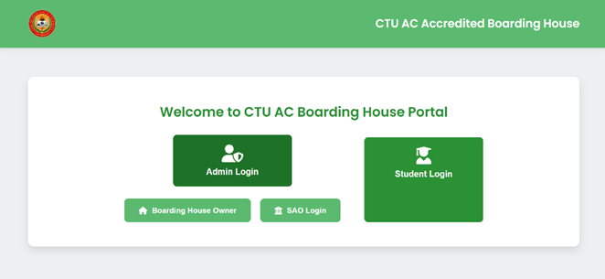

Fig. 13 Starting page

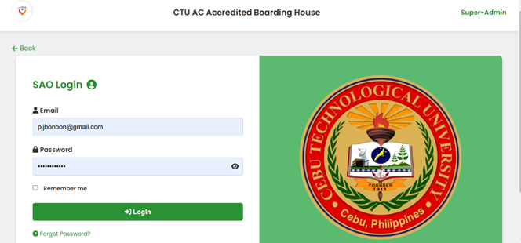

Fig. 14 SAO Login

This figure shows the Login Page of the system. You can choose whether to login as Boarding House Owner, SAO or as a Student.

This is where SAO would need to login their respective accounts. They would need to input their email and password.

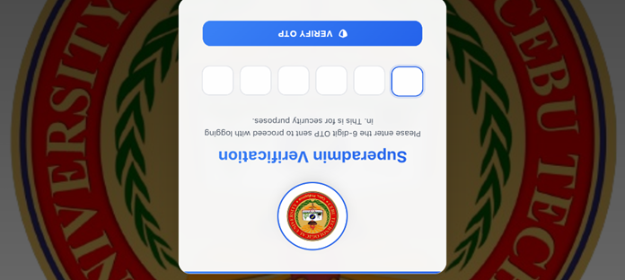



Fig. 15 Login SAO Verification

Fig. 15 SAO Forgot Password

Helps users to change their password if they forgot it. Just input their email and birthdate then if the system found their email, it will send a link through an email after which they can set a new password.

After clicking the login button, the SAO staff will need to check their emails for a OTP code to verify their identity. After that they will be redirected to SAO Dashboard.

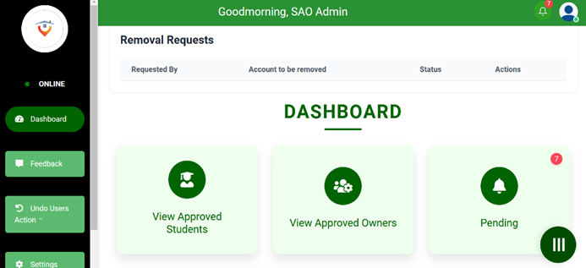

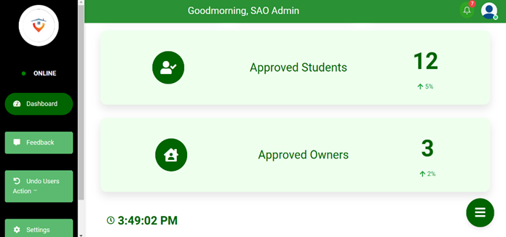

Fig. 13 SAO Dashboard

Fig. 13 SAO Dashboard

This is where the SAO staff could decide if they want to view approved students and owners. They could also view pending Owners and Students.

This could also view the statistics of students and owners.

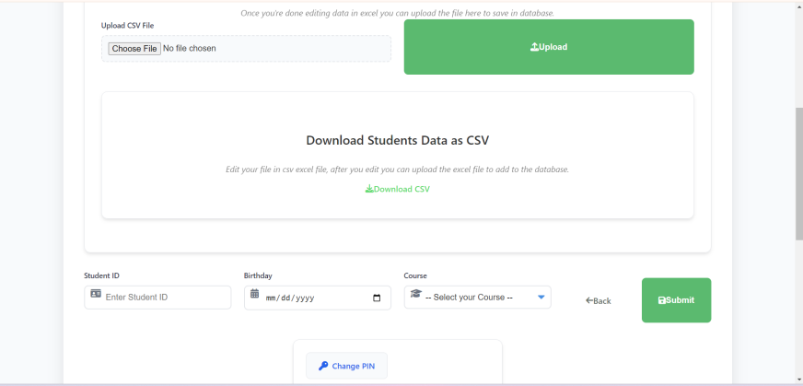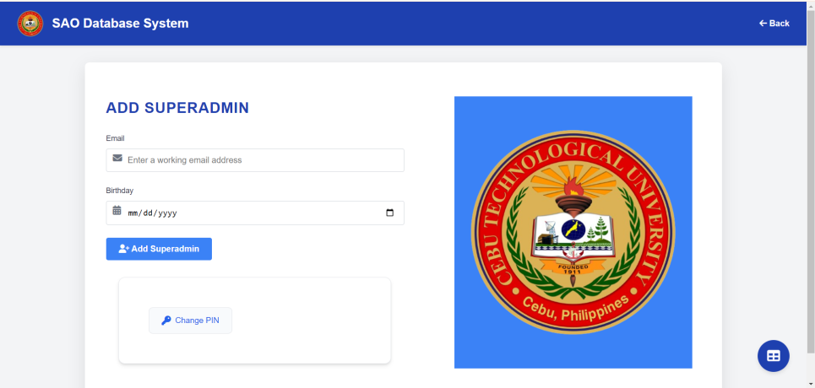

This part is where you add student details and then it will served to matched the students signup. You can add data by using excel and then upload it, and can download data saved from database.

Fig. 13 Adding student details

Fig. 13 Create SAO accounts

In here we can add a sao admin account, to open this you need a pin code. User can change pincode, and also remove sao accounts, when you are removing a sao account, a voting is then served.

Fig. 13 Approved Students

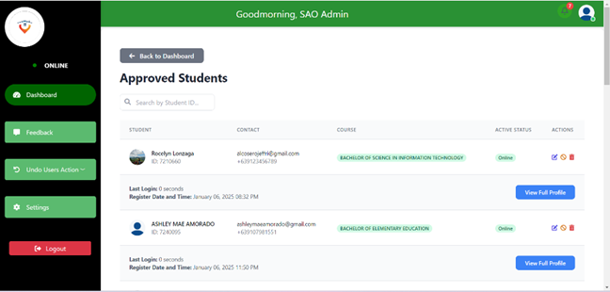

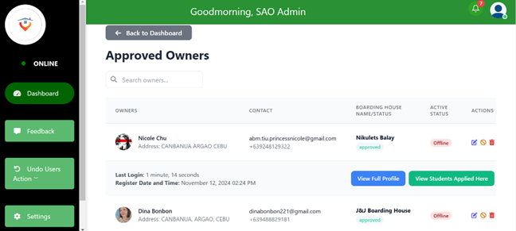

Fig. 13 Approved Students

Fig. 13 Approved Owners

In the approved students section, the SAO have the option to view, update, disable or remove the Student users. If they choose to view student then they could see the personal information of that particular student, if they choose update then they can edit the information of student, if they choose disable then the student can still login but will be unable to apply for boarding. Lastly, if they choose remove student then the student could no longer login to the system.

Same with the approved students section, the SAO have the option to view, update, disable or remove the Owner users. If they choose to view owner then they would see the personal information of that particular owner, if they choose update then they can edit the information of owner, if they choose disable then the owner can still login but will be unable to apply for boarding. Lastly, if they choose remove owner then the owner would no longer be able to login to the system.

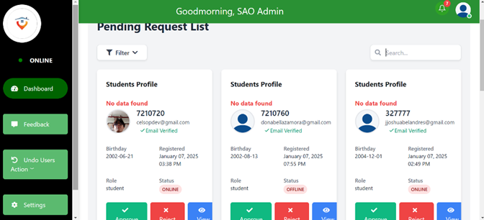

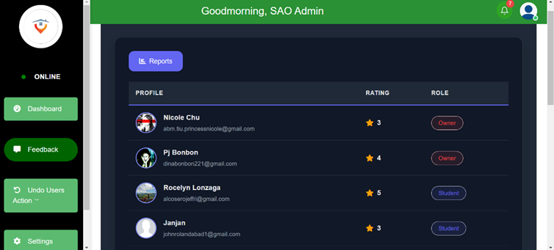

Fig. 13 System overall feedback

Fig. 13 User pending request

Pending requests would appear here, the SAO would be able to view both students and owners and decide if they want to approve or reject the requests. The filter function helps with specifying the list of whether the target would be owners or students. The search function also makes things faster and simpler just like the filter function.

In this figure, it shows the overall ratings given by students and owners. This will help the developers and the SAO to further improve the system.

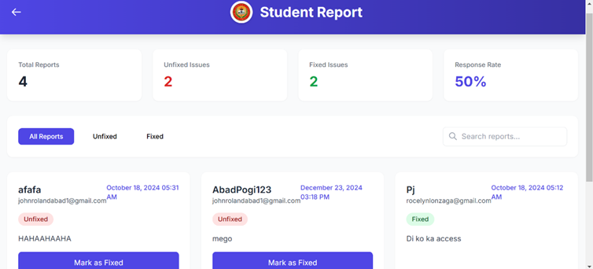

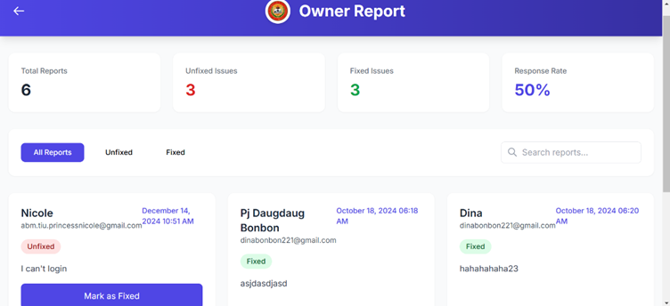

Fig. 13 Fix owner report

Fig. 13 Fix student report

Here, all reports that are made by the students will be read so we can help and solve the students problem regarding with their experience in the system.

Here, all reports that are made by the owners will be read so we can help and solve the owners problem regarding with their experience in the system.

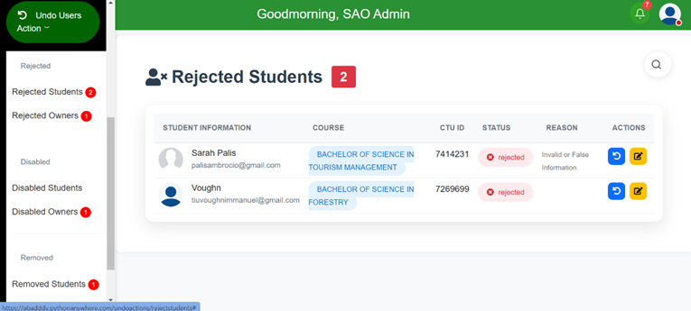

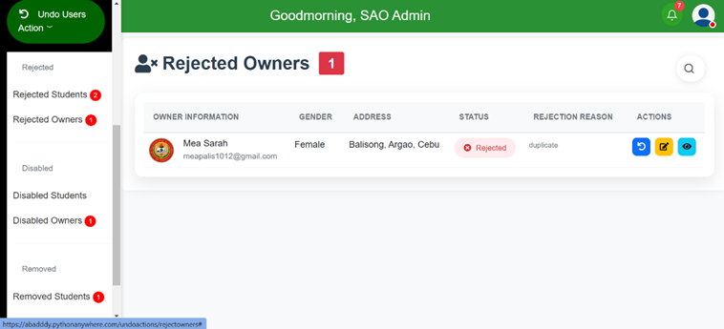

Fig. 13 Rejected owners

Fig. 13 Rejected students

In the Rejected Students section, SAO can restore the students that they rejected and they could also update some of the students information, in case the student request it.

In the Rejected Owners section, SAO can restore the students that they rejected and they could also update some of the owners information, in case the owner request it.

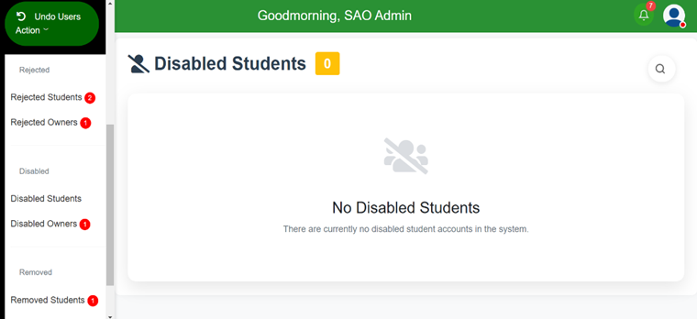

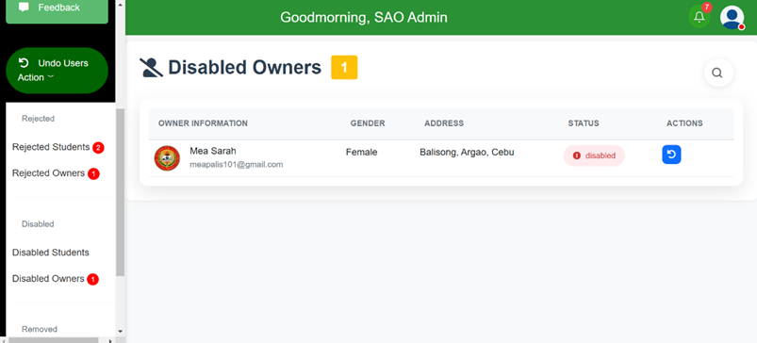

Fig. 13 Disabled students

Fig. 13 Disabled owners

In the Disabled Students section, SAO can re-enable the students that they disabled.

In the Disabled Owners section, SAO can re-enable the owners that they disabled.

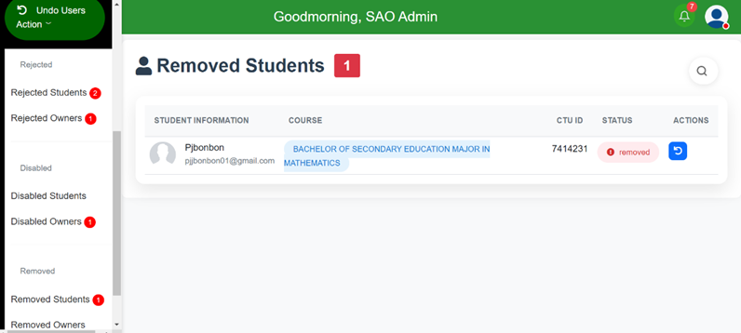

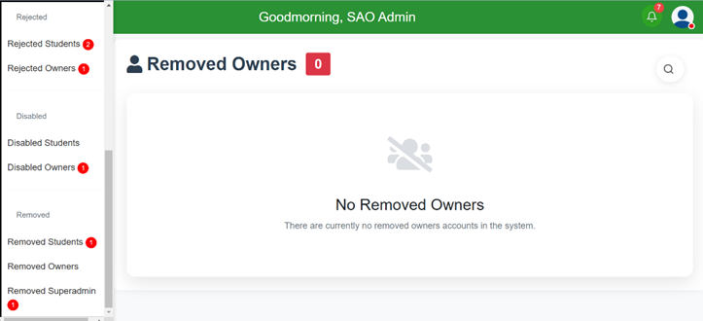

Fig. 13 Removed owners

Here, they could also undo the removal of owners.

Here, they could undo the removal of the students .

Fig. 13 Removed students

Fig. 13 Login Page

Here, they could also undo the removal of the owners.

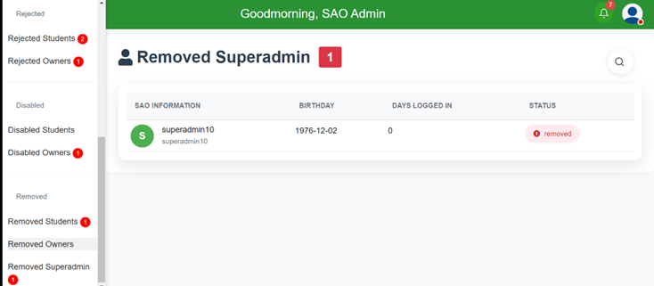

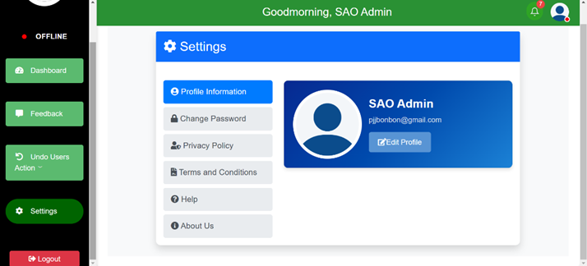

Fig. 13 Removed Superadmin

Fig. 13 SAO Settings

Here, they could see the removed Super admin or Sao. Once removed, it could not be recover to it’s role again. The removal of the Super admin will be done by voting of SAO admins and the majority of votes will win.

Here in Settings is where they could edit their personal information, change their password and see the Privacy Policy, Terms and Conditions, Help section and About Us of this system.

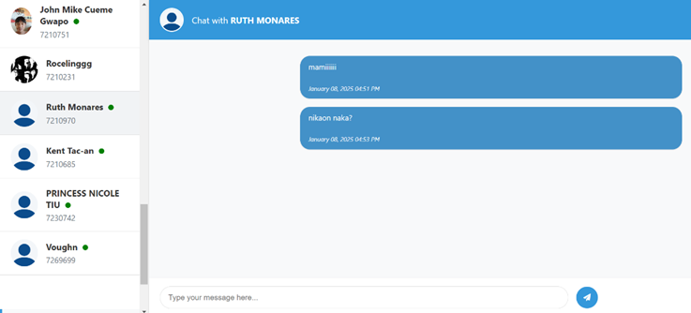

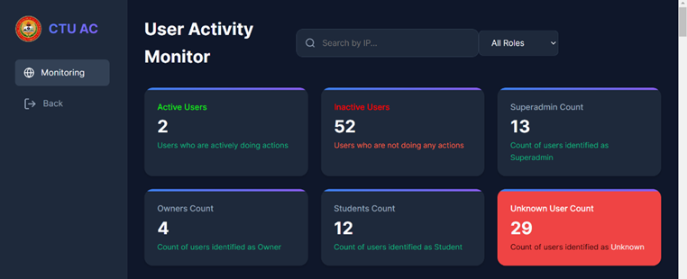

Fig. 13 Monitor users

Fig. 13 Messages

This figure shows where SAO could interact with both the user students and owners. This will help them communicate faster and relay their questions or problems more easily.

This figure shows where SAO could monitor all users that are interacting with the system. It will help in monitoring and managing user and user activities faster.

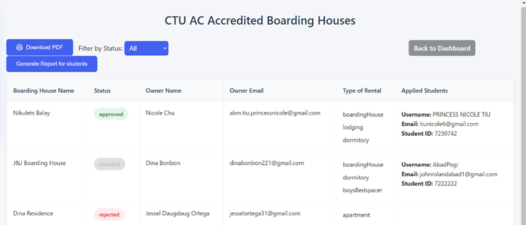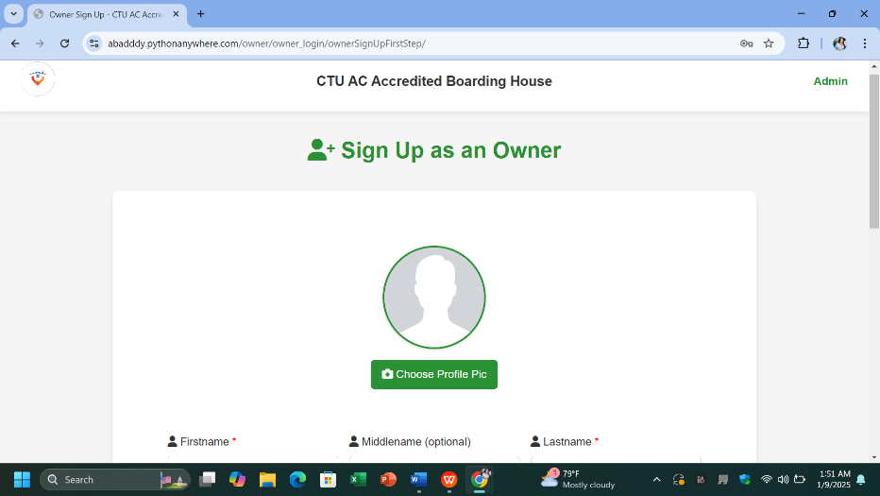

The owner can upload the profile picture, this is the signup form.

Fig. 13 Signup Owner

Fig. 13 Generate Reports

In Generate reports area, SAO can generate reports of all students or owners and download it in pdf format for easy and convenient conversion of data to soft copy.

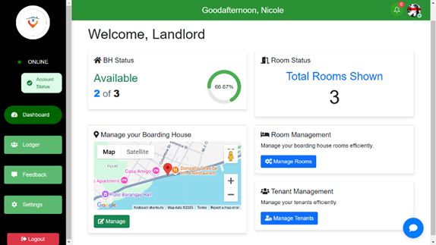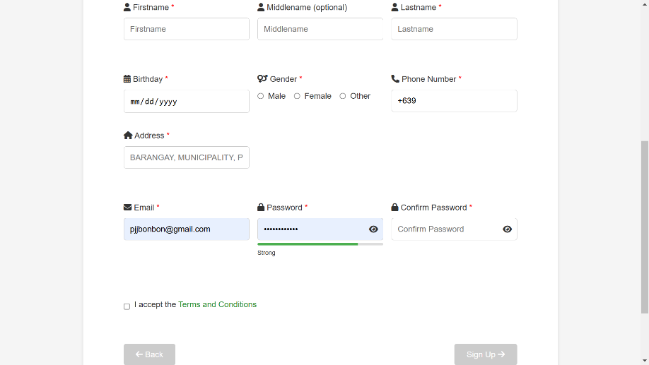

Fig. 13 Signup owner

The figure above illustrates the dashboard where the owner can view the number of available rooms remaining, and the locations of the boarding houses are also displayed.

Here,the owner of the boarding houses can input their personal information into the system.

Fig. 13 Owner Dashboard

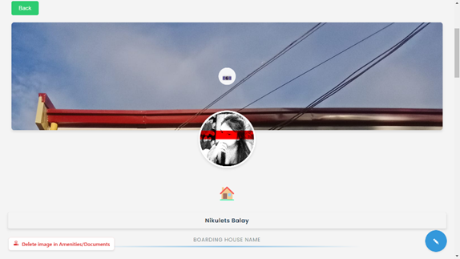

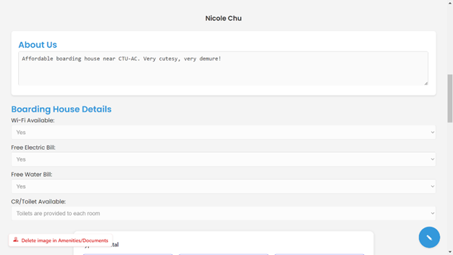

Fig. 13 Manage Boarding house (2)

Fig. 13 Manage Boarding house (1)

Manage Boarding House (Mid1)

Here you can set the security feature, the amenities of the boarding houses by answering yes or no. Also the input type for the about us, here the owner can input the details of their boarding houses that we have not covered.

Manage Boarding House (Top)

Here you can change the cover photo of the boarding house which will be the image display for astudents to find boarding house.

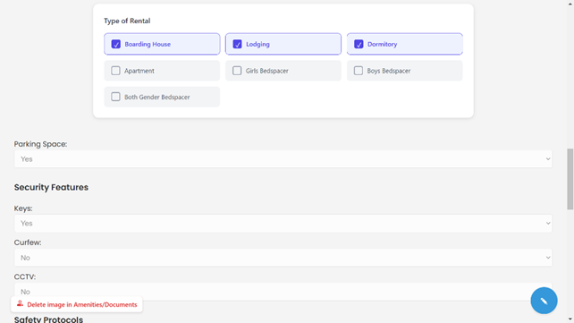

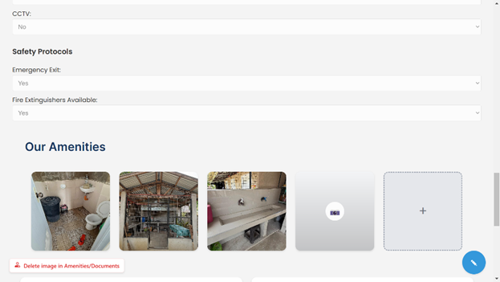

Manage Boarding House (Mid2)

Here you can set the security feature, the amenities of the boarding houses by answering yes or no. Also the input type for the about us, here the owner can input the details of their boarding houses that we have not covered.

Fig. 13 Manage Boarding house (3)

Manage Boarding House (Mid3)

This part, the security features are answered by owners, this all starting from the (Top) is displayed by the students to let them know the details of the boardinghouse. This is where the images for the amenities is uploaded.

Fig. 13 Manage Boarding house (4)

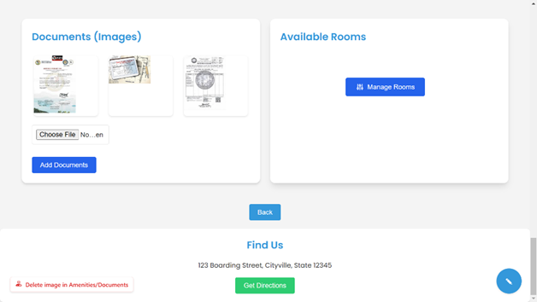

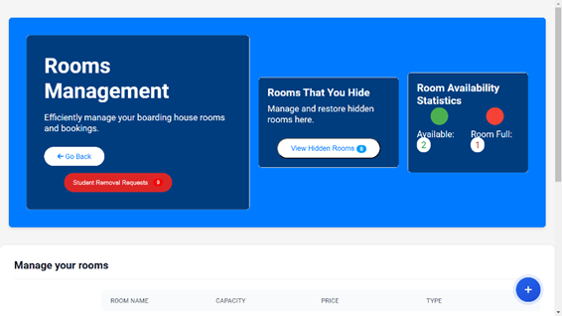

Manage Boarding House (Bot)  
Here is the part where the owners uploaded documents and in the manage rooms.

Fig. 13 Room Management (1)

Fig. 13 Manage Boarding house (5)

Room Management

Here in room management the owner will manage rooms like editing room details and person staying on that room. The owner can also view student removal requests here.

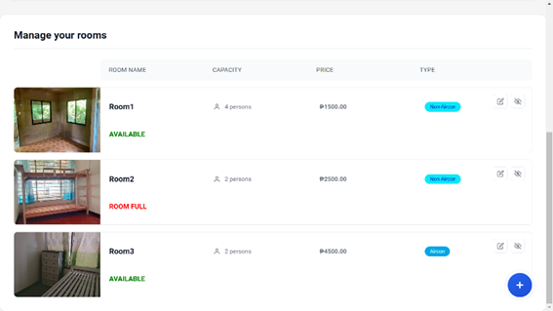

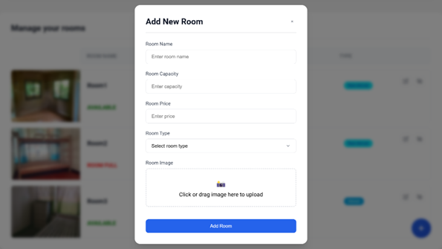

Fig. 13 Room Management (2)

Here, owners could manage their rooms. For example adding a room or updating an existing room.

This is where owners could add a room and input the information of the new room.

Fig. 13 Adding rooms

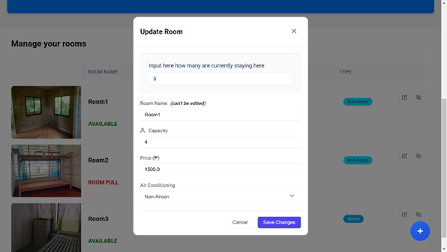

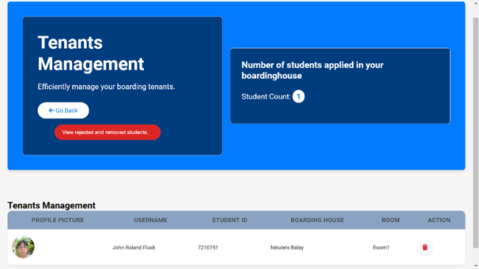

This is where they could manage student users / tenants, they can view their rejected students and remove the student applied.

This is where they could update the existing room.

Fig. 13 Update rooms

Fig. 13 Tenants Management

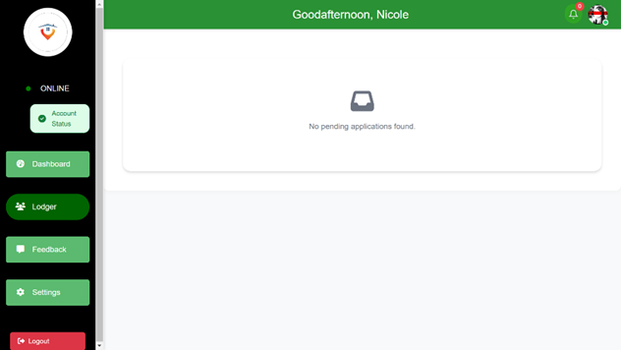

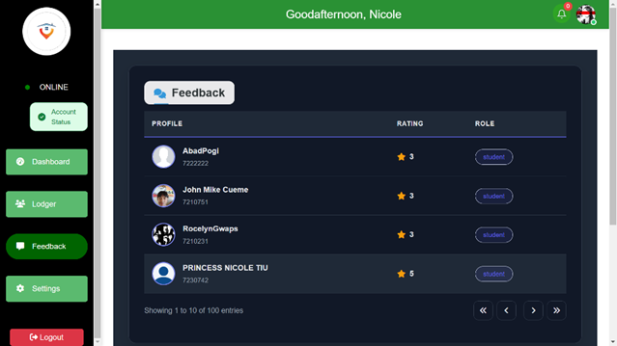

The illustration above depicts the Feedback section where Admin can view the ratings on the system or services provided. This feature helps gather valuable insights to improve user satisfaction and overall system performance.

.

Fig. 13 Owner Feedback

Pending requests of the students that applied on this lodger would be display here.

Fig. 13 Student applied to owner’s boarding house

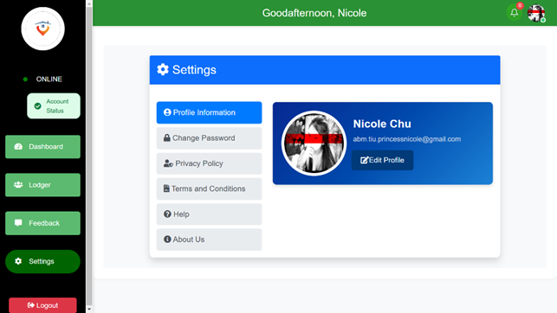

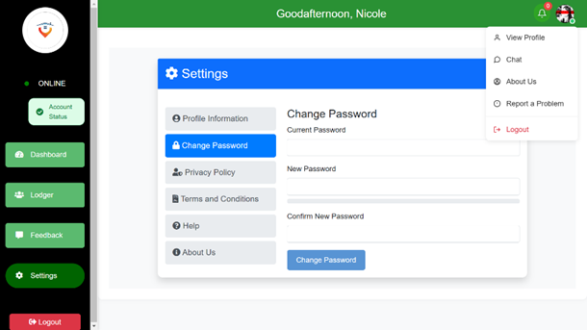

Fig. 13 Owner Change Password

The illustration above shows the Profile Information section, where users can view and update their personal details, such as name, contact information, and preferences, ensuring their account remains accurate and up-to-date.

.

The illustration above depicts the Change Password feature for Admin, enabling users to securely update their login credentials to maintain account security and privacy.

.

Fig. 13 Owner Edit Profile

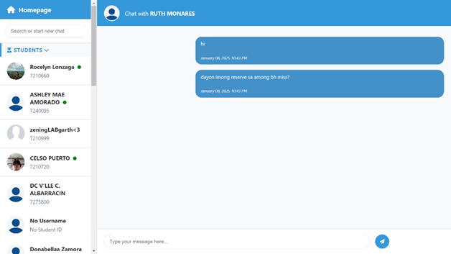

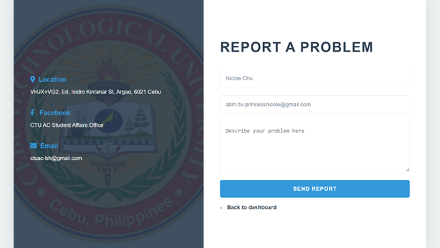

The illustration above highlights how owners interact with both the SAO and students, showcasing the connections and collaboration between them.

Fig. 13 Messages

This is where you can report a problem once you already log in.

Fig. 13 Owner Reporting a problem

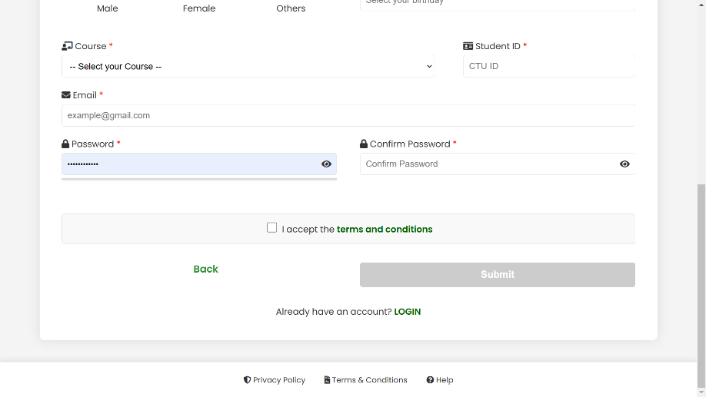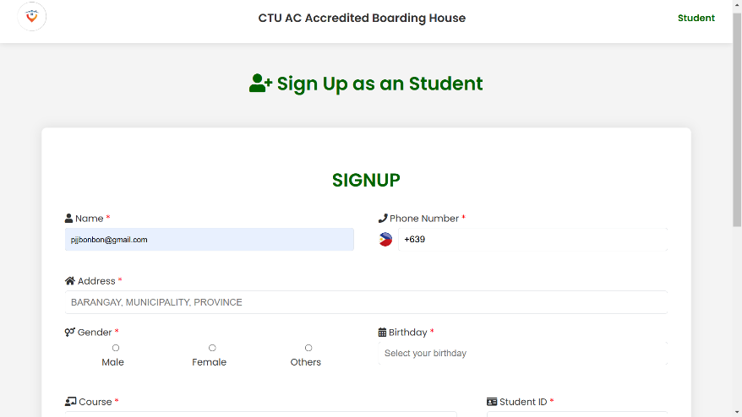

The signup form of the student, this is where the student input their details including their email and password.

Fig. 13 Signup student

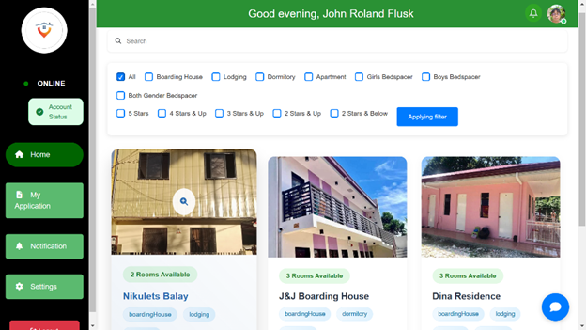

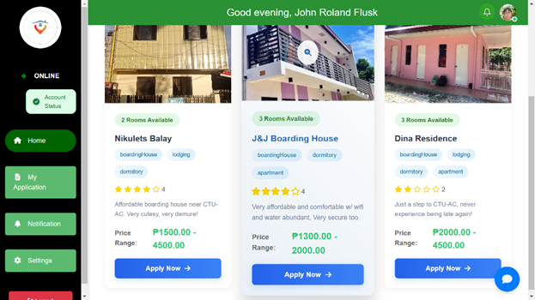

Fig. 13 Student Dashboard

The illustration above showcases the Student Homepage, In here the user can apply boarding house on their choice.

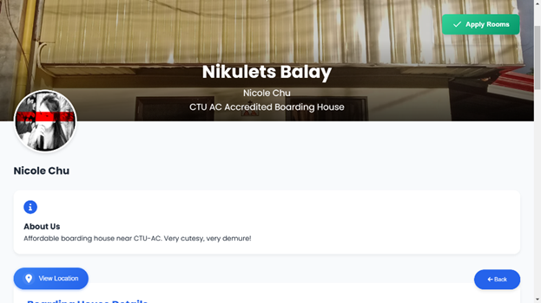

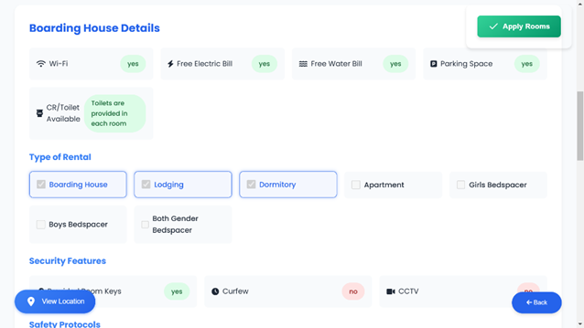

The illustration above presents the Boarding House Details section, providing comprehensive information about the boarding house, including its address and other relevant details to assist users in making informed decisions.

The illustration above presents the Boarding House Details section, providing comprehensive information about the boarding house, including profile picture and cover photo.

Fig. 13 Viewing of Boardinghouse (1)

Fig. 13 Viewing of Boardinghouse (2)

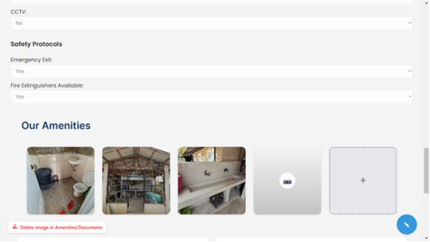

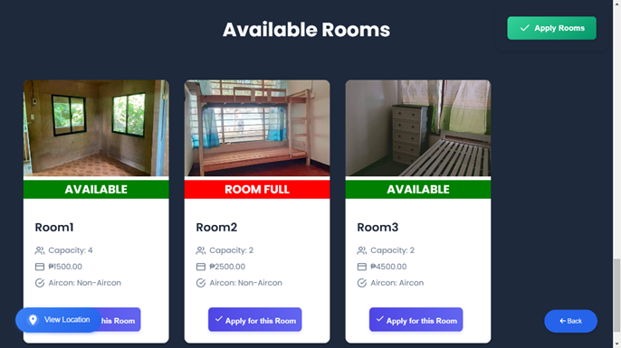

The figure above depicts the Available Rooms section, where users can browse and view details of vacant rooms, including pricing, and occupancy status. This feature helps users make informed decisions when selecting a room.

Fig. 13 Viewing of Boardinghouse (4)

The figure above highlights the Our Amenities section, showcasing the facilities and services available to residents, such as Wi-Fi, laundry, common areas, and other features designed to enhance their stay.

Fig. 13 Viewing of Boardinghouse (3)

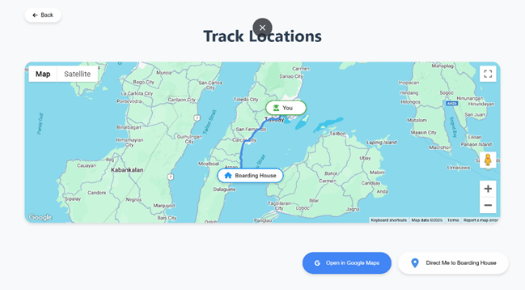

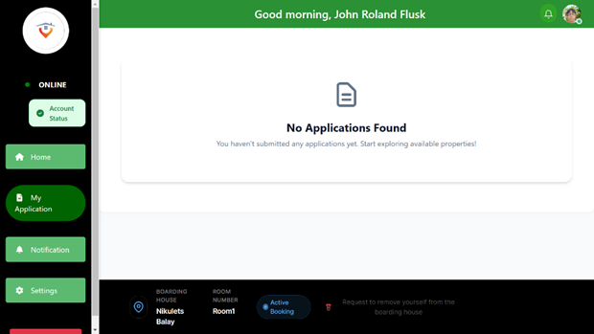

Fig. 13 Student Application

Fig. 13 Tracking of Location

The figure above shows the Track Locations section, where users can locate the boarding house or nearby essential facilities on an interactive map. This feature enhances user convenience by providing accurate directions and location details.

The figure above illustrates the My Application section, where users can track the status of their boarding house application, view submitted details, and receive updates. This feature provides a convenient way for users to monitor and manage their application process.

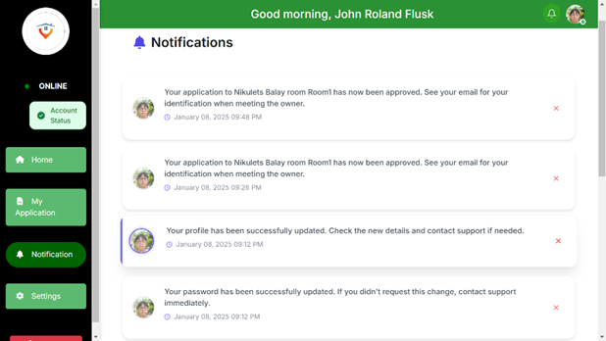

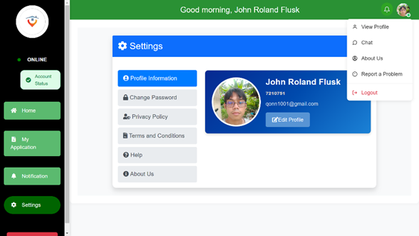

Fig. 13 Student Edit profile

The figure above illustrates the Profile Information section, where users can view and update their personal details, such as contact information and preferences. This feature ensures that users can keep their profile up-to-date for seamless communication and management.

The figure above shows the Notifications section, where users can view important updates, reminders, and alerts related to their account or activities within the system. This feature ensures that users stay informed and up-to-date on relevant information.

Fig. 13 Notification

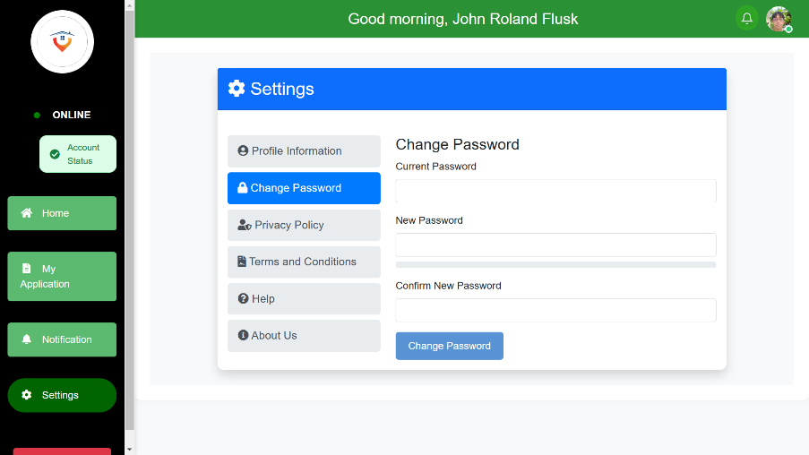

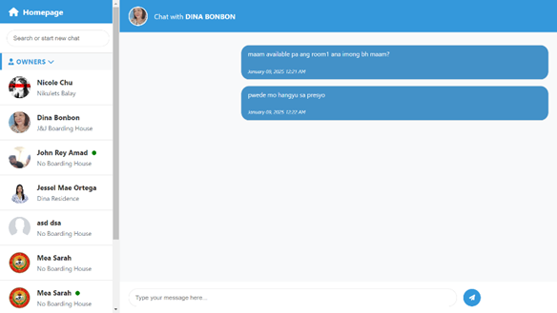

The figure above depicts the Change Password section, where users can securely update their login credentials. This feature enhances account security by allowing users to modify their passwords as needed.

Fig. 13 Messages

The figure above shows the Real-time communication section, where users can directly communicate with the boarding house owners. This feature facilitates real-time interaction for inquiries, concerns, or important updates, ensuring effective communication between users and owners.

Fig. 13 Student change password

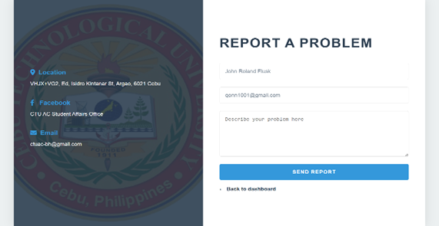

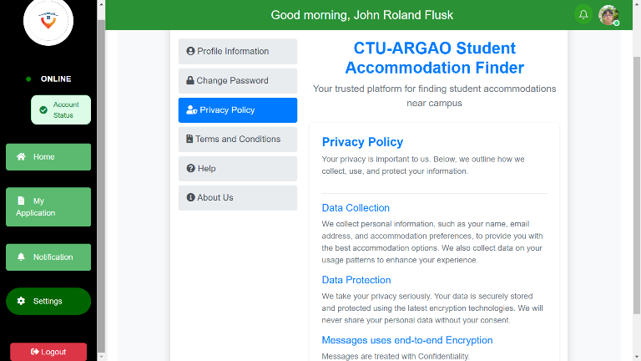

The figure above shows the Privacy Policy section, where users can review how their personal information is collected, used, stored, and protected. This section ensures transparency and informs users of their data privacy rights while using the system.

Fig. 13 Student Report a problem

The figure above illustrates the Report a Problem section, where users can report any issues or concerns they encounter while using the system. This feature ensures that problems are promptly addressed to improve user experience and system performance.

Fig. 13 Privacy Policy

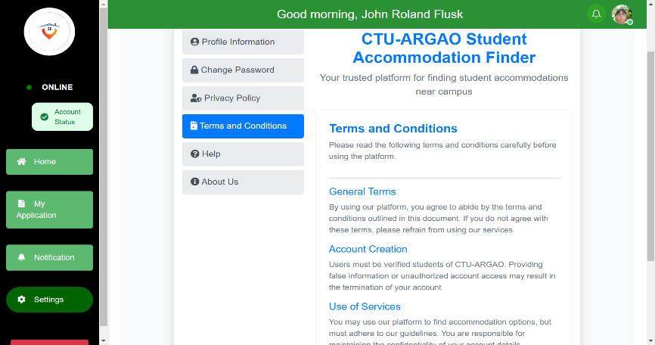

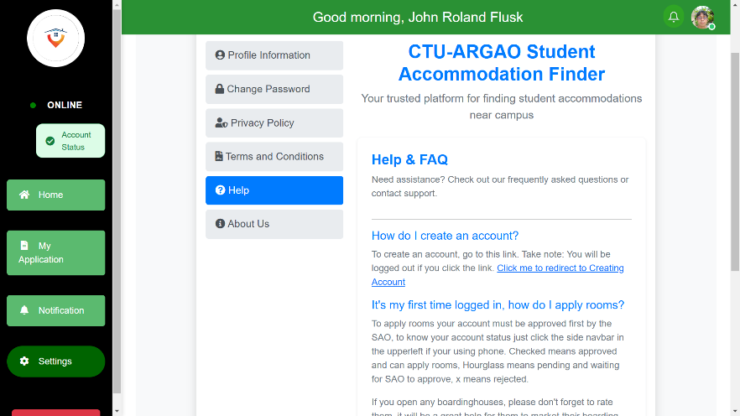

Fig. 13 Help

Fig. 13 Terms and Conditions

This section represents the Help feature, where users can seek assistance whenever they encounter difficulties or require support while using the system.

The figure above depicts the Terms and Conditions section, where users can review the guidelines, rules, and policies governing the use of the system. This section ensures that users are informed about their rights and responsibilities while using the platform.

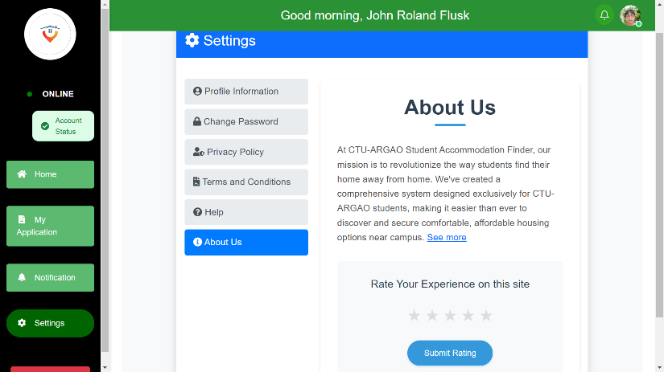

Fig. 13 About us

The figure above illustrates the About Us section, where users can learn more about the system and provide feedback by rating their experience on the platform.

**BIBLIOGRAPHY**

1. Periodicals/Journals/Magazines
2. Oktavallyan, S. D., Seftyarizki, D., & Wardhani, F. (2021, April). Student boarding house quality in term of health design (Case Study: Boarding house near University of Bengkulu). IOP Conference Series: Earth and Environmental Science, 738(1), 012027. IOP Publishing.

<https://iopscience.iop.org/article/10.1088/1755-1315/738/1/012027/meta>

https://iopscience.iop.org/article/10.1088/1755-1315/738/1/012027/meta

1. Wahyudi, I. R., Irsyad, F. D., & Azmi, L. (2023). Website-Based Boarding Rental Information System Design. International Journal of Research and Applied Technology (INJURATECH), 3(1), 31-40.

<https://ojs.unikom.ac.id/index.php/injuratech/article/view/9871/3753>

1. S. Kristianto. (2022). Analysis and Rental of Boarding House Information System in Tangerang City. bit-Tech, 5(1), 25–36.

<https://jurnal.kdi.or.id/index.php/bt/article/view/529>

1. Development Of A Boarding House Search Information System Using The Waterfall Model. (2021). Yudha Dwi Putra Negara, Dwi Rizal Setiawan, Eka Mala Sari Rochman, & Fifin Ayu Mufarroha. E3S Web of Conferences, 328, 04030.

<https://www.e3sconferences.org/articles/e3sconf/abs/2021/104/e3sconf_icstunkhair2021_04030/e3sconf_icstunkhair2021_04030.html>

1. Rachmadi, A., Asyhab, N., Fauzi, M. D., & Mulyanto, A. (2016). A Web-Based Boarding House Information System in Yogyakarta. IJID (International Journal on Informatics for Development), 5(1), 21–29.

[https://doi.org/10.14421/ijid.2016.05104](https://www.e3sconferences.org/articles/e3sconf/abs/2021/104/e3sconf_icstunkhair2021_04030/e3sconf_icstunkhair2021_04030.html)

1. Suwitno, S., Chandra, N. D., & Daniawan, B. (2023). Boarding House Provider Information with Multi Attribute Utility Theory (MAUT) Method. bit-Tech, 5(3), 155–165.

<https://jurnal.kdi.or.id/index.php/bt/article/view/729>

1. Bustillo, R. G., & Batistis, B. G. Boarding House Locator and Student Monitoring System in Naval, Biliran Province, Philippines. International Journal of Engineering Sciences & Research Technology.

[https://scholar.google.com/scholar?hl=en&as_sdt=0%2C5&q=boarding+house+tracking+sys](https://jurnal.kdi.or.id/index.php/bt/article/view/729)

1. Thesis/Dissertation
2. Wahyudi, I. R., Irsyad, F. D., & Azmi, L. (2023). Website-Based Boarding Rental Information System Design. International Journal of Research and Applied Technology (INJURATECH), 3(1), 31-40.

[https://ojs.unikom.ac.id/index.php/injuratech/article/view/9871/3753](https://jurnal.kdi.or.id/index.php/bt/article/view/729)

1. Online Resources
2. Bustillo, R. G., & Batistis, B. G. Boarding House Locator and Student Monitoring System in Naval, Biliran Province, Philippines. Accessible online for quick reference.

[https://scholar.google.com/scholar?hl=en&as_sdt=0%2C5&q=boardinghouse+tracking+sys](https://scholar.google.com/scholar?hl=en&as_sdt=0,5&q=boarding+)

**APPENDICES**

**Appendix A: Transmittal Letter**

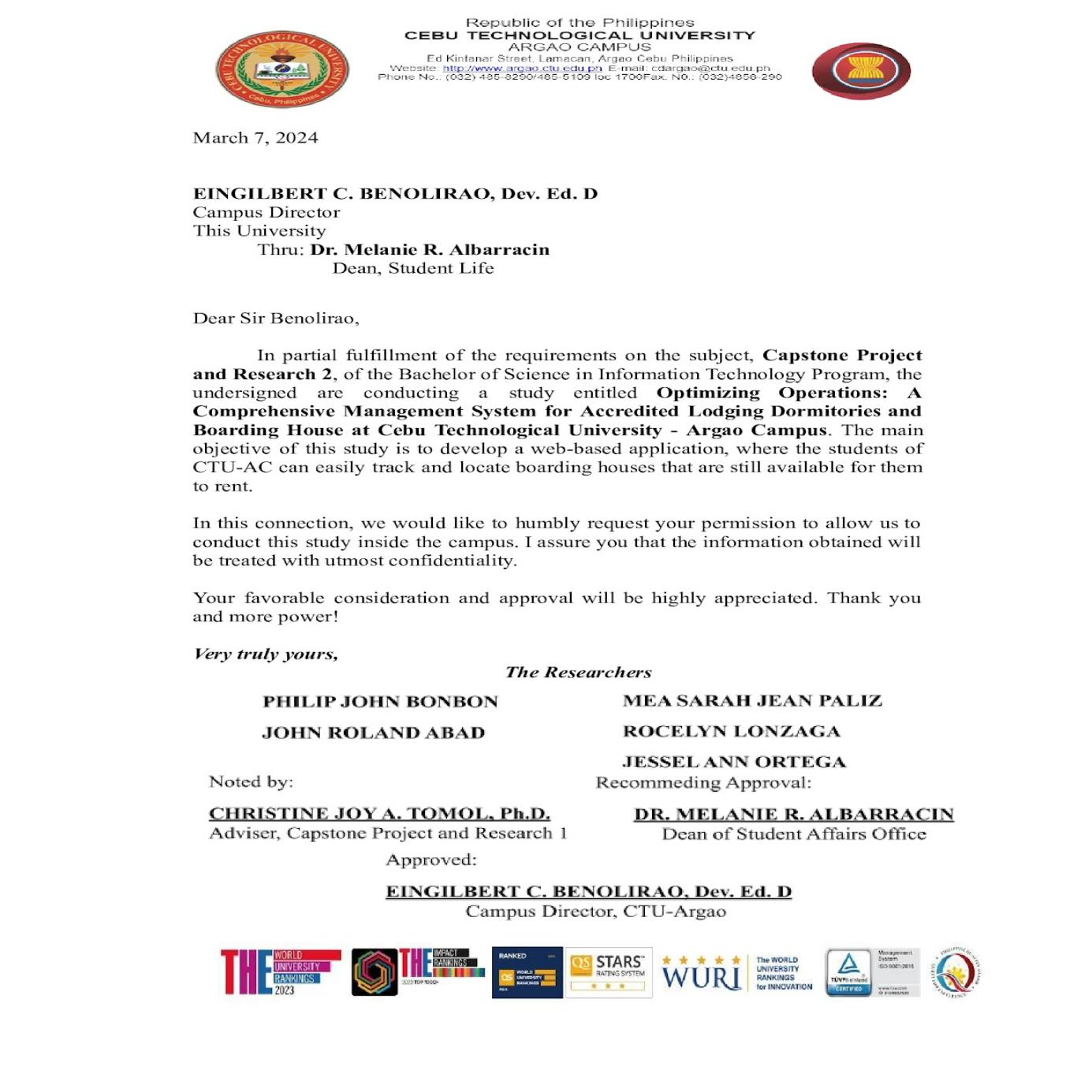  
  
 We are Team DataLink, students currently engaged in our Capstone Project and Research 2 at Cebu Technological University – Argao Campus. As part of our course requirements, we are developing a project entitled **“Optimizing Operations: A Comprehensive Management System for Accredited Lodging Dormitories and Boarding Houses at Cebu Technological University - Argao Campus.”** This system is designed to improve the management processes for accredited lodging facilities associated with CTU-Argao Campus. In support of this effort, we kindly request a few moments of your time to respond to our questionnaire. Your insights and feedback are invaluable in helping us refine and enhance this system to meet the needs of the CTU-Argao Campus community. Thank you for your consideration and participation.

I.  **Personal Information**

**Name(Optional): _______________________________________________**

DEPARTMENT:

[ ] COED [ ] CAS [ ] CAFE [ ] CHMT [ ] COTE

1. What type of boarding facility are you currently staying in?

[ ] Dormitory

[ ] Boarding House

[ ] Apartment

[ ] Bedspacer

[ ] Lodging

1. How did you find your current boarding house?

[ ] Referral from friends or family

[ ] University housing office

[ ] Online listing

[ ] Walk-in/Personal inquiry

[ ] Other (please specify): _______________________________

**II. Current status of Boarding House Management System of Argao Cebu as accredited CTU-AC SAO** Please indicate by putting a [✓] mark. Use the rating scale below.

|  |  |  |
| --- | --- | --- |
| **Rating** | **Scale** | **Meaning** |
| Fully Complied (FC) | 3 | MEETS ALL REQUIREMENTS |
| Partially Complied (PC) | 2 | MEETS SOME REQUIREMENTS. |
| Not Complied (NC) | 1 | DOESN'T MEET ANY REQUIREMENTS |

|  |  |  |  |  |
| --- | --- | --- | --- | --- |
| **No.1** | **What is the current status of Boarding House Management System of Argao Cebu as accredited CTU-AC SAO in terms of?** | **3** | **2** | **1** |
| 1. **Accreditation** | | | | |
| 1 | The accreditation process make the boarding house safer and more comfortable for residents. |  |  |  |
| 2 | The boarding house provide the necessary documents and information to stay accredited. |  |  |  |
| 3 | The accreditation improves the overall quality of life for residents. |  |  |  |
| 4 | The boarding house system cover aspects you believe are essential for accreditation (such as safety, comfort, cleanliness). |  |  |  |
| 5 | The boarding house system, as it is currently, will meet the requirements for future accreditation. |  |  |  |
| 1. **Room Allocation** | | | | |
| 1 | Rate the fairness of the room allocation process. |  |  |  |
| 2 | The students able to easily request or select specific rooms. |  |  |  |
| 3 | Students receive enough information about their assigned rooms (e.g., room type, cost). |  |  |  |
| 4 | The boarding house system avoid issues with overbooking or room shortages? |  |  |  |
| 5 | How satisfied are you with the communication provided during the room allocation process? |  |  |  |
| 1. **Safety and Security** | | | | |
| 1 | How well does the boarding house meet safety standards? |  |  |  |
| 2 | How would you rate the overall security measures in place (e.g., surveillance, security personnel)? |  |  |  |
| 3 | Emergency exits are easy to find and access. |  |  |  |
| 4 | The boarding house provide safety equipment, like fire extinguishers, for emergencies? |  |  |  |
| 5 | Curfew is effectively enforced to ensure the safety of residents. |  |  |  |
| 1. **Accommodation** | | | | |
| 1 | The accommodations provided by the boarding house meet your personal needs. |  |  |  |
| 2 | The boarding house provide a comfortable and inviting living environment. |  |  |  |
| 3 | The amenities (e.g., common areas, Wi-Fi) sufficient to meet your daily requirements. |  |  |  |
| 4 | How satisfied are you with the quality of furniture and appliances provided? |  |  |  |
| 5 | The boarding house environment conducive to studying and personal relaxation. |  |  |  |
| 1. **Communication** | | | | |
| 1 | The communication between boarding house management and residents are effective. |  |  |  |
| 2 | You are promptly informed about updates, events, or important information by the management team. |  |  |  |
| 3 | The management team for addressing resident concerns or inquiries is accessible. |  |  |  |
| 4 | There is a clear and reliable way to reach management in case of emergency or urgent matters. |  |  |  |
| 5 | Residents are encouraged to provide feedback or suggestions to improve the boarding experience. |  |  |  |
| 1. **Maintenance Management** | | | | |
| 1 | How well-maintained are the boarding house facilities in terms of cleanliness? |  |  |  |
| 2 | Repair requests are handled promptly by the management. |  |  |  |
| 3 | How satisfied are you with the frequency and thoroughness of facility inspections? |  |  |  |
| 4 | The maintenance management ensure that common areas are clean and usable at all times. |  |  |  |
| 5 | The facilities, such as plumbing, electricity, and air conditioning, are regularly maintained and functioning well. |  |  |  |

**SOFTWARE EVALUATION: INTERNAL AND EXTERNAL QUALITY**

(Adopted from International Standard ISO/IEC 9126-1:2001)

**Rater:**

[ ] User

[ ] IT expert

**Overview:**

The ISO 9126 software is a widely recognized global standard for evaluating the quality of software. It provides a comprehensive framework for assessing software, which can be divided into four categories, each addressing different aspects. This software is widely used to incorporate various models and metrics. When software is evaluated, the recommended features are described externally and internally, based on the attributes of the software. This quality model helps determine the software's functionality, reliability, usability, efficiency, maintainability, and portability, which are the six characteristics used to assess software quality. Each characteristic is further divided into related sub-characteristics, which are listed in the evaluation form.

**Direction:**

To determine if a program is sustainable, an assessment is necessary. This assessment involves examining whether the program possesses the expected traits of sustainable software. The more traits it has, the more sustainable it will be. To perform the assessment, each characteristic must be rated on a scale of 1

to 4, with 4 being the highest rating and 1 being the lowest.

|  |  |  |  |  |  |  |  |
| --- | --- | --- | --- | --- | --- | --- | --- |
| **Range** | **Rating Scale** | **Functionality** | **Reliability** | **Usability** | **Efficiency** | **Maintainability** | **Portability** |
| 3.26-4.00 | 4 | Very Functional | Very Reliable | Very  Usable | Very  Efficient | Very  Maintainable | Very Portable |
| 2.51 -  3.25 | 3 | Functional | Reliable | Usable | Efficient | Maintainable | Portable |
| 1.76 -  2.50 | 2 | Slightly Functional | Slightly Reliable | Slightly Usable | Slightly Efficient | Slightly Maintainable | Slightly Portable |
| 1.00 -  1.75 | 1 | Not Functional | Not Relliable | Not Usable | Not Efficient | Not Maintainable | Not Portable |

|  |  |  |  |  |
| --- | --- | --- | --- | --- |
| **SOFTWARE EVALUATION CRITERIA** | **RATING** | | | |
| **FUNCTIONALITY** | **VF(4)** | **F(3)** | **SF(2)** | **NF(1)** |
| Suitability  ● The capability of the software  product to provide an  appropriate set of functions for  specified tasks and user  objectives. |  |  |  |  |
| Accuracy  ● The capability of the software  product to provide the right or  agreed results or effects with  the needed degree of precision. |  |  |  |  |
| Interoperability  ● The capability of the software  product to interact with one or  more specified systems. |  |  |  |  |
| Security  ● The capability of the software  product to protect information  and data so that unauthorized  persons or systems cannot read  or modify them and authorized  persons or systems are not  denied access to them. |  |  |  |  |
| Functionality Compliance  ● The capability of the software  product to adhere to standards  conventions or regulations in  laws and similar prescriptions  relating to functionality. |  |  |  |  |
| **RELLIABILITY** | **VR (4)** | **R(3)** | **SR(2)** | **NR(1)** |
| Maturity  ● The capability of the software  product to avoid failure as a  result of faults in the software. |  |  |  |  |
| Fault-Tolerance  ● The capability of the software  product to maintain a specified  level of performance in cases of  software faults or infringement  of its specified interface. |  |  |  |  |
| Recoverability  ● The capability of the software  product to re-establish a  specified level of performance  and recover the data is directly  affected in the case of a failure. |  |  |  |  |
| Reliability Compliance  ● The capability of the software  product to adhere to standards,  conventions, or regulations  relating to reliability. |  |  |  |  |
| **USABILITY** | **VU(4)** | **U(3)** | **SU(2)** | **NU(1)** |
| Understandability  ● The capability of the software  product to enable the user to  understand whether the  software is suitable and how it  can be used for particular tasks  and conditions of use. |  |  |  |  |
| Learnability  ● The capability of the software  product to enable the user to  learn its application. |  |  |  |  |
| Operability  ● The capability of the software  product to enable the user to  operate and control it. |  |  |  |  |
| Attractiveness  ● The capability of the software  product to be attractive to the  user. |  |  |  |  |
| Usability Compliance  ● The capability of the software  product to adhere to standards,  conventions, style guides, or  regulations relating to usability. |  |  |  |  |
| **EFFICIENCY** | **VE(4)** | **E(3)** | **SE(2)** | **NE(1)** |
| Time-Behavior  ● The capability of the software  product to provide appropriate  response and processing times  and throughput rates when  performing its function under  stated conditions. |  |  |  |  |
| Resource Utilization  ● The capability of the software  product to use appropriate  amounts and types of resources  when the software performs its  function under stated  conditions. |  |  |  |  |
| Efficiency Compliance  ● The capability of the software  product to adhere to standards  or conventions relating to  efficiency. |  |  |  |  |
| **MAINTAINABILITY** | **VM(4)** | **M(3)** | **SM(2)** | **NM(1)** |
| Analyzability  ● The capability of the software  product to enable a specified  modification to be implemented. |  |  |  |  |
| Changeability  ● The capability of the software  product to avoid unexpected  effects from modifications of the  software. |  |  |  |  |
| Stability  ● The capability of the software  product to continue functioning  if changes are made. |  |  |  |  |
| Testability  ● The capability of the software  product to enable modified  software to be validated. |  |  |  |  |
| Maintainability Compliance  ● The capability of the software  product to adhere to standards  or conventions relating to  maintainability. |  |  |  |  |
| **PORTABILITY** | **VP(4)** | **P(3)** | **SP(2)** | **NP(1)** |
| Adaptability  ● The capability of the software  product to be adapted for  different specific environments  without applying actions or  means other than those  provided for this purpose for the  software considered. |  |  |  |  |
| Installability  ● The capability of the software  product to be installed in a  specified environment |  |  |  |  |
| Co-existence  ● The capability of the software  product to co-exist with other  independent software in  a common environment sharing  common resources |  |  |  |  |
| Replaceability  ● The capability of the software  product to be used in place of  another specified software  product for the same purpose in  the same environment. |  |  |  |  |
| Portability Compliance  ● The capability of the software  product to adhere to standards  or conventions relating to portability |  |  |  |  |
|  |  |  |  |  |

**SOFTWARE EVALUATION: CRITERIA-BASED ASSESSMENT**

**(Perceived Usefulness and Perceived Ease-of-Use, and User Acceptance of Information Technology)**

Range Rating Scale Perceived Usefulness Perceived Ease-of-Use

3.26 - 4.00 4 Very Useful Very Easy To Use

2.51 - 3.25 3 Useful Easy To Use

1.76 - 2.50 2 Partially Useful Not So Easy To Use

1.00 - 1.75 1 Not Useful Not Easy To Use

|  |  |  |  |  |
| --- | --- | --- | --- | --- |
| **SOFTWARE EVALUATION CRITERIA** | **RATING** | | | |
| **Perceived Usefulness** | **VU(4)** | **U(3)** | **RU(2)** | **NU(1)** |
| 1. Utilizing the system at work  would allow me to complete  tasks faster |  |  |  |  |
| 2. In my line of work, the system is  useful |  |  |  |  |
| 3. Making use of the system would  improve my efficiency in the  workplace |  |  |  |  |
| 4. Utilizing the system at work  would boost my productivity |  |  |  |  |
| 5. Making use of the system would  improve my job performance |  |  |  |  |
| 6. Making use of the system would  simplify or ease my job |  |  |  |  |

|  |  |  |  |  |
| --- | --- | --- | --- | --- |
| **Perceived Ease-of-Use** | **VE(4)** | **E(3)** | **NSE(2)** | **NE(1)** |
| 1. My interaction with the system is  clear and understandable |  |  |  |  |
| 2. By using the system, it would be  easy for me to become skillful |  |  |  |  |
| 3. By using the system, I would find  it flexible to interact with me |  |  |  |  |
| 4. The system is user-friendly to me |  |  |  |  |
| 5. I would find it easy to delegate  tasks to the system |  |  |  |  |
| 6. Operating the system would be  easy to learn |  |  |  |  |

**Appendix C: Project Working Title Form**



**CAPSTONE PROJECT AND RESEARCH 1(TECHNOPRENEURSHIP)**

**PROJECT WORKING TITLE FORM**

**Proponents:**

|  |
| --- |
| 1. Philip John D. Bonbon |
| 1. John Roland Abad |
| 1. Mea Sarah Jean F. Palis |
| 1. Rocelyn Lonzaga |
| 1. Jessel Ann Ortega |

**Approved Project Working Title:**

|  |
| --- |
| **Optimizing Operations: A Comprehensive Management System for Accredited Lodging Dormitories and Boarding House at Cebu Technological University - Argao Campus** |

**Submitted by:**

**PHILIP JOHN D. BONBON**

(Signature of Team Manager or Hacker over printed name)

________________

Date

**Noted:**

**MORRIS DAYAGANON, MSIT**

(Signature of Project Adviser over printed name)

_

_______________

           Date

**DR. CHRISTINE JOY TOMOL**

(Signature of Subject Adviser over printed name)

_______________

           Date

**Approved:**

**DR. CHRISTINE JOY TOMOL**

(Signature of the Chairperson over printed name)

_____________________

       Date

**Appendix D: Project Adviser Appointment Form**

  
**CAPSTONE PROJECT AND RESEARCH 1**

**PROJECT ADVISER APPOINTMENT FORM**

This is to formally appoint      **DR. RYAN H. TEO** as the adviser of the Capstone Project of the following proponents:

|  |  |  |
| --- | --- | --- |
| **Proponent** | **Job Description/Roles** | **Signature** |
| Philip John D. Bonbon | Hacker/Hustler |  |
| John Roland Abad | Hacker/Hustler |  |
| Mea Sarah Jean Palis | Hacker/Hipster |  |
| Rocelyn Lonzaga | Hacker |  |
| Jessel Ann Ortega | Hustler |  |

**Conforme:**

**Noted:**

**DR. RYAN H. TEO   DR. CHRISTINE JOY TOMOL**

Signature of the Project Adviser over      Signature of the Subject Adviser over Printed name                                          Printed name

___________________________          ________________________________

Date                                               Date

**Approved:**

**DR. CHRISTINE JOY TOMOL**

Chairperson

  _____________________________________

                           Date

**Appendix E: Curriculum Vitae**



**Philip John D. Bonbon**

**Cell No.:09959578322**

**Canbanua, Argao, Cebu**

**A. Personal Background**

Name: Philip John D. Bonbon  
Position: 4th Year Student  
Address: San Miguel Street Canbanua Argao Cebu  
Birth Date: January 7, 2003  
Birth Place: Argao Memorial Hospital  
Citizenship: Filipino  
Religion: Born Again  
Email Address: <pjjbonbon@gmail.com>  
**B. Educational Background  
Elementary**Canbanua Elementary School  
2013-2014  
  
**Junior High School**Argao National High School  
Canbanua Argao Cebu  
2017-2018  
  
**Senior High School**Argao National High School  
Canbanua Argao Cebu  
Accountancy, Business and Management  
(ABM)  
2020-2021  
  
**College**Cebu Technological University  
Bachelor of Science in Information Technology  
Present  
  
**C. Relevant Skills**Computer literacy, Coding skills, Critical thinking  
  
**D. Seminar and Training Experiences**freelance web developer  
TESDA NCII CSS



**John Roland R. Abad  
Cell No.: 09634889418**

**Jampang, Argao, Cebu**

1. **Personal Background**

Name: John Roland R. Abad  
Cell No.: 09634889418  
Position: 69  
Address: Jampang, Argao, Cebu  
Birthdate: April 13, 2002  
Birthplace: Sta. Cruz Manila  
Citizenship: Filipino   
Religion: Roman Catholic  
Email Address: <johnrolandabad1@gmail.com>  
**B. Educational Background**

**Elementary**  
Jampang Elementary School   
Jampang, Argao, Cebu  
With Honors

**Junior High**  
Argao National High School   
Canbanua, Argao, Cebu  
With Honors

**Senior High**Argao National High School   
Canbanua, Argao, Cebu  
With Honors

**College**   
Cebu Technological University  
Bachelor of Science in Information Technology  
Present  
  
**C. Relevant Skills**  
Key Skills:  
Programming: Python, Java, C++, C, C#, JavaScript  
Web Development: HTML, CSS  
  
Soft Skills: Flexibility, Problem-solving, Teamwork, Communication, Multitasking, Basic troubleshooting  
  
**D. Seminar and Training Experience**Computer Systems Servicing NC II



**Mea Sarah Jean F. Palis   
Balisong, Argao, Cebu  
09430733929**

**A. Personal Background**

Name: Mea Sarah Jean F. Palis   
Position: 4th Year Student  
Address: Balisong, Argao, Cebu  
Birth Date: May 13, 2002  
Birth Place: Dalas-ag, Argao, Cebu  
Citizenship: Filipino  
Religion: Roman Catholic  
Email Address: <sarahpalis9@gmail.com>  
**B. Educational Background**

**Elementary**

Balisong-Casay Elementary School  
Balisong, Argao, Cebu   
  
**Junior High School**Casay National High School  
Casay ,Dalaguete, Cebu   
  
**Senior High School**Casay National High School  
Casay, Dalaguete, Cebu   
(General Academic Strand)  
2020-2021  
  
**College/University**  
Cebu Technological University - Argao Campus  
Lamacan, Argao, Cebu  
Bachelor of Science in Information Technology  
2021 - Present



Rocelyn R. Lonzaga  
Cell No.: 09502263789

Calagasan, Argao, Cebu

1. **Personal Background**Name: Rocelyn R. Lonzaga  
   Position: 4th Year Student  
   Address: Calagasan, Argao, Cebu  
   Birth Date: July 08, 2002  
   Birth Place: Calagasan, Argao, Cebu  
   Citizenship: Filipino  
   Religion: Roman Catholic  
   Email Address: rocelynlonzaga@gmail.com  
     
   **B. Educational Background**

**Elementary**  
Calagasan Elementary School  
Calagasan, Argao, Cebu   
  
**Junior High School**Calagasan National High School  
Calagasan, Argao, Cebu   
  
**Senior High School**Calagasan National High School  
Calagasan, Argao, Cebu   
(General Academic Strand)  
2020-2021  
  
**College/University**  
Cebu Technological University - Argao Campus  
Lamacan, Argao, Cebu  
Bachelor of Science in Information Technology  
2021 - Present



**JESSEL ANN ORTEGA   
Prenza , Talaga, Argao, Cebu  
09633814155**

**A. Personal Background**Name: Jessel Ann Ortega   
Position: 4th Year Student  
Address: Prenza, Talaga, Argao, Cebu  
Birth Date: September 14, 2002  
Birth Place: Prenza,Talaga, Argao, Cebu  
Citizenship: Filipino  
Religion: Roman Catholic  
Email Address: jesselortega31@gmail.com  
  
**B. Educational Background**Elementary  
Talaga Elementary School  
Talaga, Argao, Cebu   
  
**Junior High School**Casay National High School  
Casay ,Dalaguete, Cebu   
  
**Senior High School**Casay National High School  
Casay, Dalaguete, Cebu   
(General Academic Strand)  
2020-2021  
  
**College/University**  
Cebu Technological University - Argao Campus  
Lamacan, Argao, Cebu  
Bachelor of Science in Information Technology  
2021 - Present